Institute of World Religions, Chinese Academy of Social Sciences
Beijing, April 7, 2026

Jürgen Moltmann and His Thinker Statue
Commemorating the 100th Anniversary of Jürgen Moltmann’s Birth

Friederike Moltmann
Centre Nationale de le Recherche Scientifique

Thinker statues and thinker images form a fascinating, but little explored topic.
We are most familiar with Rodin’s rather tortured (and very male) thinker:

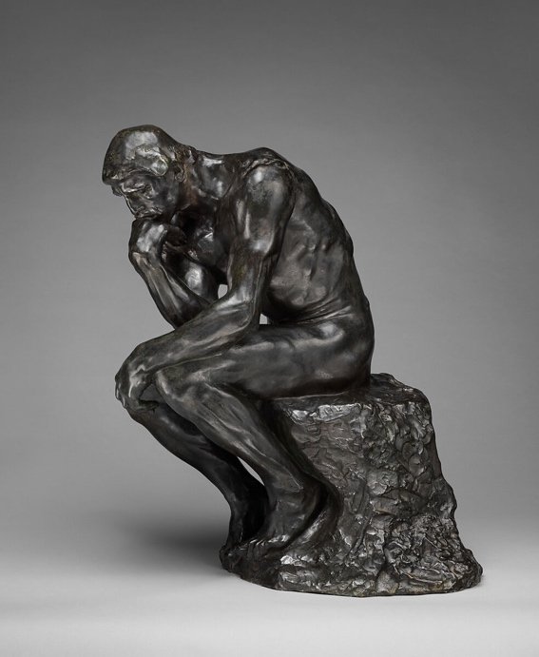
But thinker statues as well as thinker images in painting can be found in various different cultures and at different times in history, and they have played important roles both in Buddhism and Christianity, though in rather different ways.

My father Juergen Moltmann was very much drawn to one particular buddhist thinker statue, the Korean pensive bodhisattva:

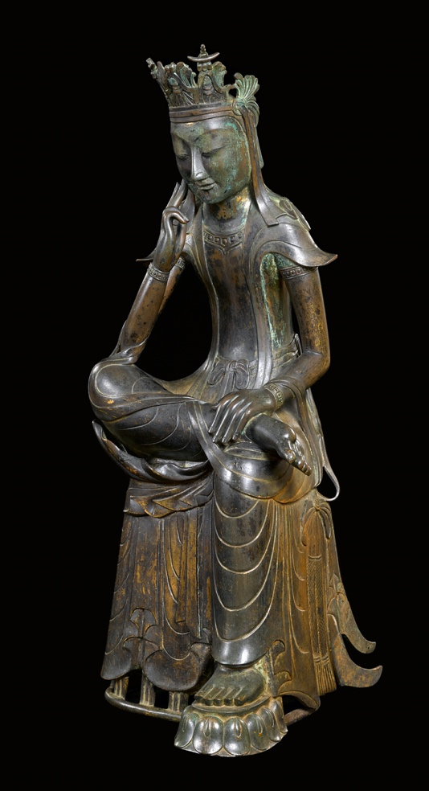

Questions this talk will address

- Why was my father so drawn to the Korean pensive bodhisattva?
- What kinds of male and female thinker statues or images occur across different cultures?
- How are thoughts represented in sculpture?
- Is there a Christian tradition of thinker statues?

Plan of the talk

- Juergen Moltmann’s favorite thinker pose and the attraction to thinker images in my family
- Juergen Moltmann’s favorite statue and the notion of hope
- Thinker statues and thinker images, male and female, throughout different cultures and historical periods
- The representations of ‘the thought’
- The Christian tradition of thinker statues: the pensive, anxious Christ statues of Noethern Eastern Europe
- The pensive Christ statue of the Dolomites, who encourages us to smile - like the Korean bodhisattva

1. Thinker images and their connection to my family

My father
Juergen Moltmann, author of the Theology of Hope

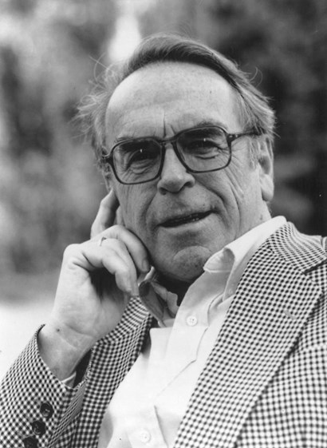

My father’s favorite statue
The Korean pensive bodhisattva:
It represents Maitreya – the buddha of the future.
Observation
The portrait above represents my father’s characteristic and favorite thinker pose!
The pose it is that of the Korean pensive bodhisattva, not that of Rodin’s thinker!
My father in early 2024 in his study:
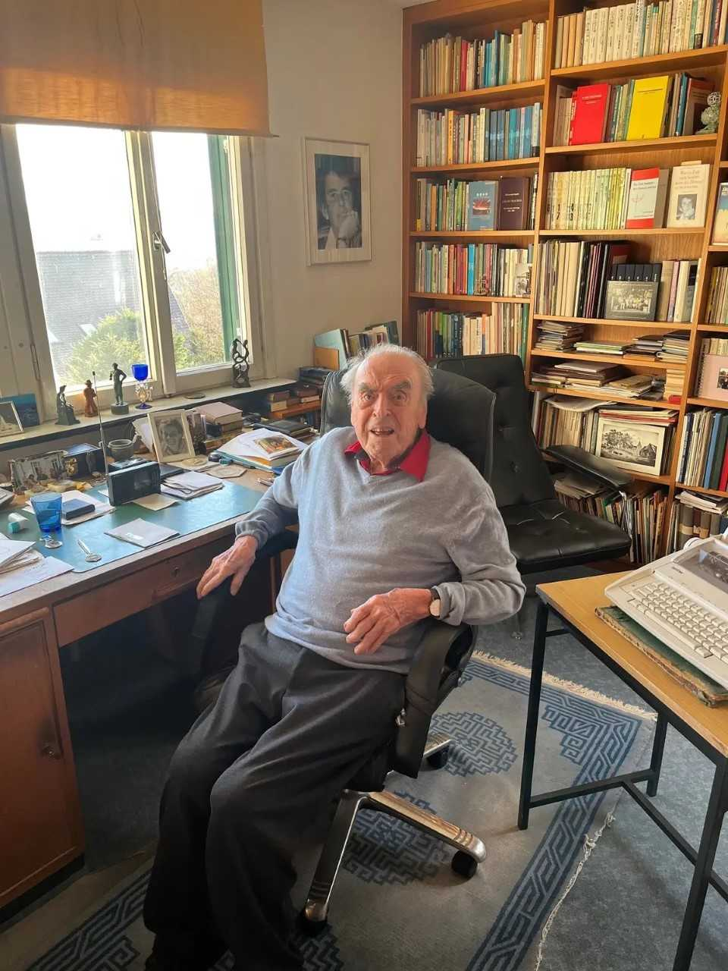

Another one of my father’s Korean thinker statues:

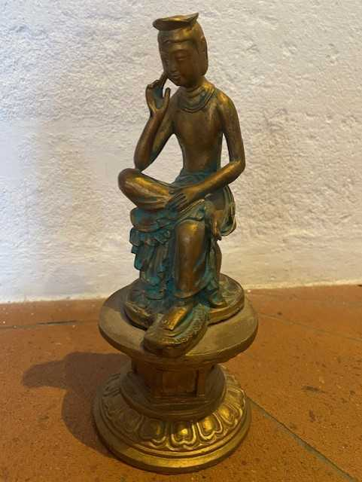

Features of the pensive Korena bodhisattva
- Very human thinking pose
- Rather feminine, representing empathy, erenity and grace:
- Smiling, though having thoughts about suffering and death

Me

Philosopher (analytic philosophy) and linguist
A recent book of mine: Objects and Attitudes (Oxford University Press 2024)
What the book is about:
Propositional attitudes, that is mental states or acts like thinking, believing, hoping, desiring, intending, planning, imagining, doubting
The book makes a new proposal regarding the objects involved in propositional attitudes
Thought, beliefs, hopes, desires, intentions, imaginations, doubts
The book’s claim
Proposiational attitudes involve mind-dependent objects such as thoughts, beliefs, hopes, desires, intentions, imaginations, doubts, not abstract sentential contents (propositions), as the philosophical tradition holds (Bolzano, Frege, Stalnaker and many others).

The chosen book cover:
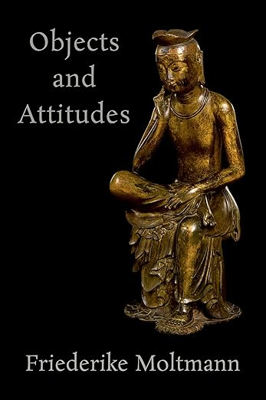
Thinker statues
- represent a propositional attitude (thinking)
- are objects
My mother
Elisabeth Moltmann-Wendel, a feminist theologian (‘Freedom, Equality, and Sisterhood’)
a thinker herself, of course.
Here my father’s favorite portrait of her in a thinker pose (see photo of my father’s study)
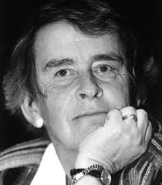

My mother was not aware of the traditions of thinker images, but this one used to be in her study:my self-portrait at the age of 15
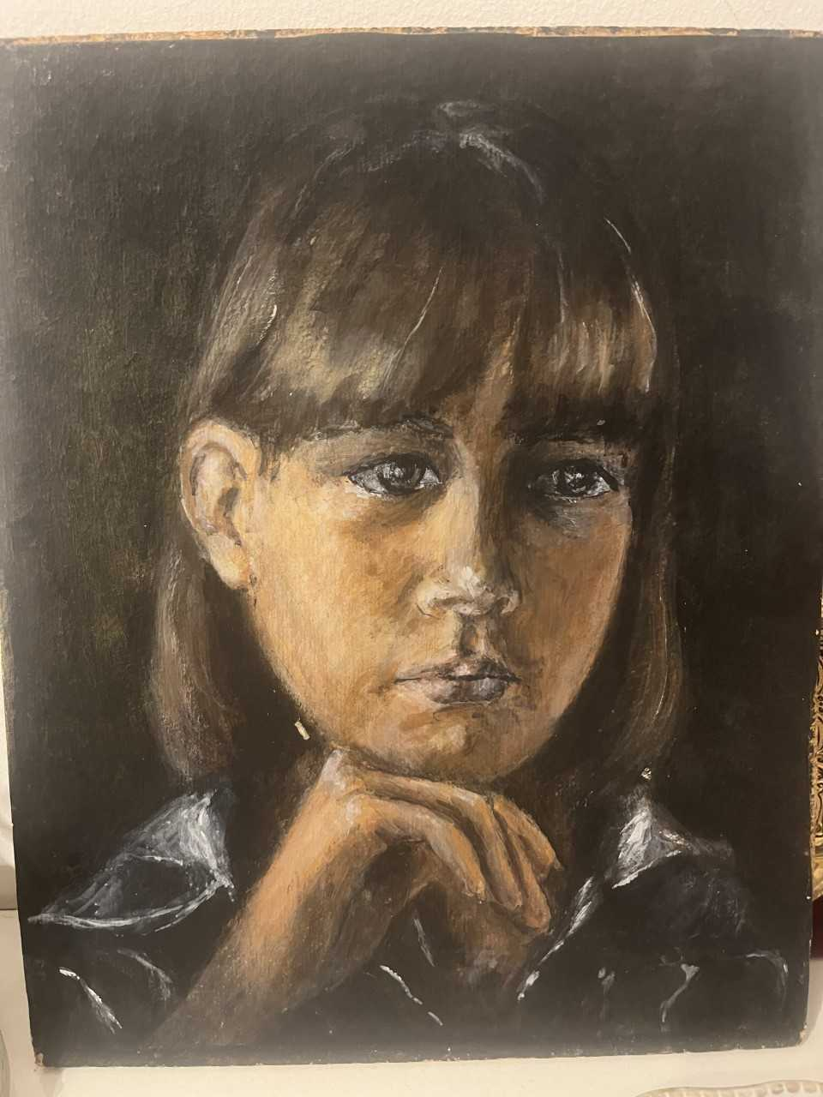
2. Juergen Moltmann’s favorite statue and the notion of hope

The Korean bodhisattva
What is a bodhisattva?
An enlightened being who postpones buddhahood in order to help human beings to their path to enlightenment
Maitreya
The buddha of the future: the buddha that comes to the world in countless years and helps humans find enlightenment
The characteristics of the Korean pensive bodhisattva image:
- Hand supporting the chin
- half lotus position
- crown (often lotus)

Two Korean national treasures (in the Korean National Museum in Seoul):

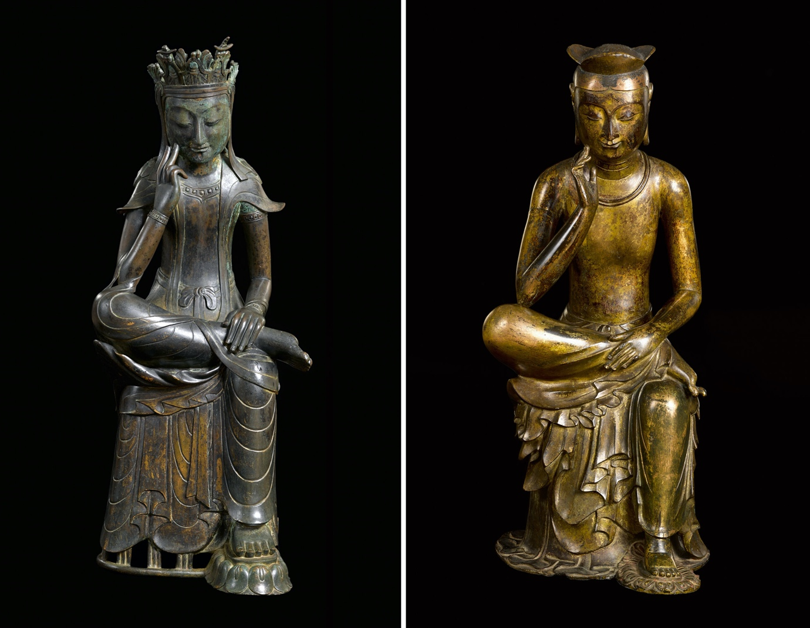
Another example:

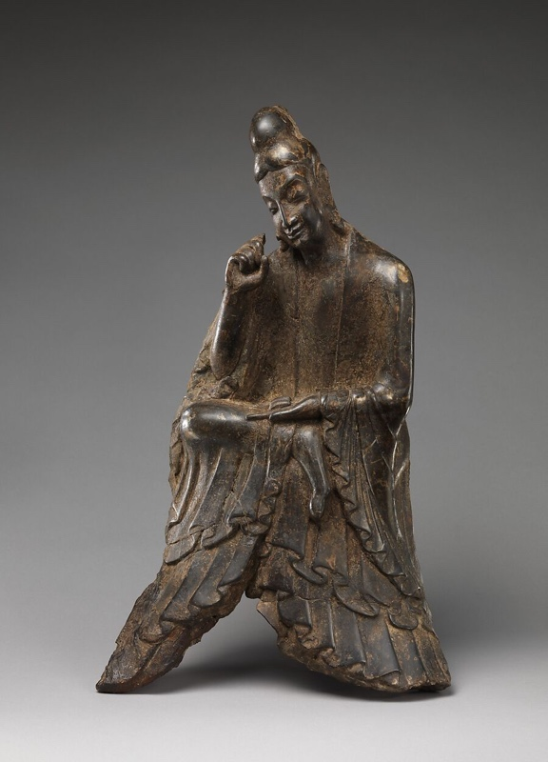

A Korean national treasure and a Japanese one (from Nara), side-by-side:

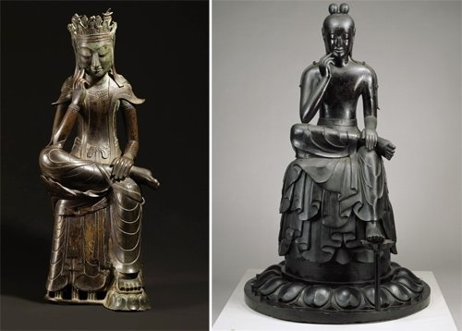

The Chinese version of maitreya
- Different seating position: crossed legs
- Different hand positions

An example from the Metropolitan Museum of Art, New York:

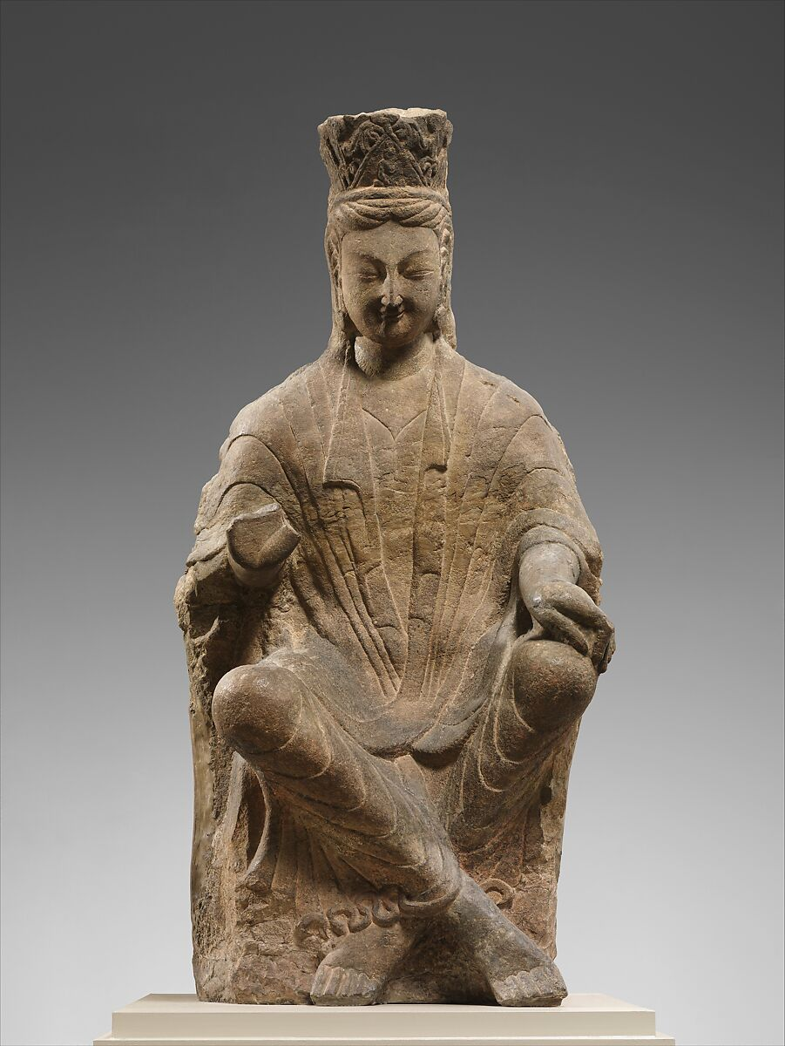

A closely related Chinese buddhist figure: Guanyin
- Typical thinker pose of the hand
- But bodily position of ‘royal ease’

An example from the Musée Guimet, Paris:

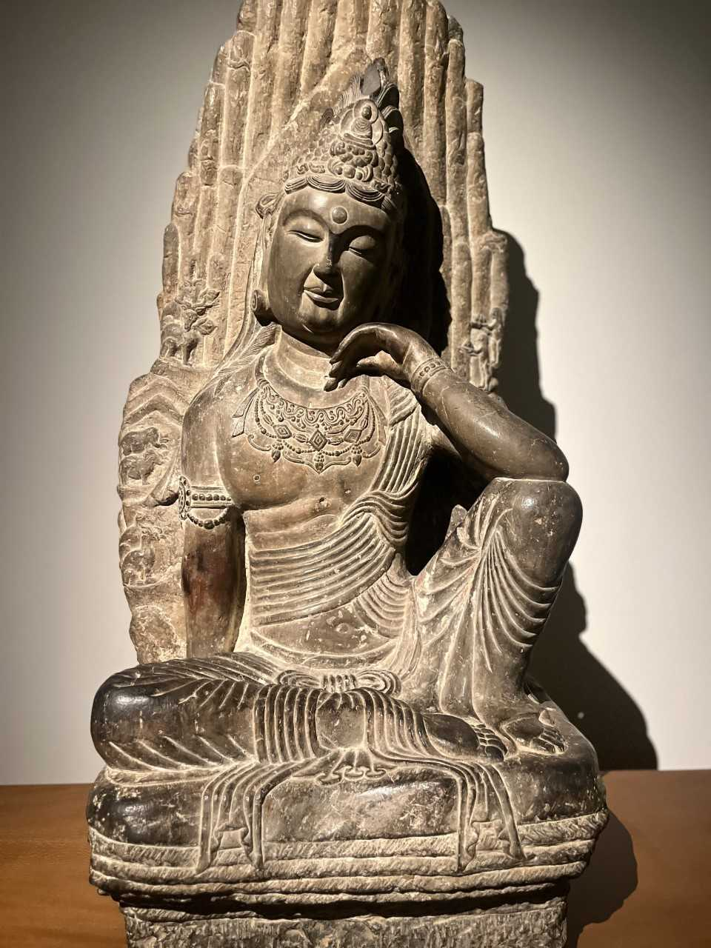
What did my father like the image of the Korean pensive bodhisattva so much?

- The notion of hope
Hope is fundamental to Christian faith
Christian hope is for the real world, not for a realm of heaven beyond it
The buddhist figure of the Maitreya
The buddha of the future that comes back to the world (in a very distant future) and helps humans obtain enlightenment, serenity, eternal joy

- Other features of attraction
The smiling face, even when being aware of death of suffering
The grace and lightness

3. Thinker statues in different cultures

3.1. Abstract thinker statues

Cycladic culture:
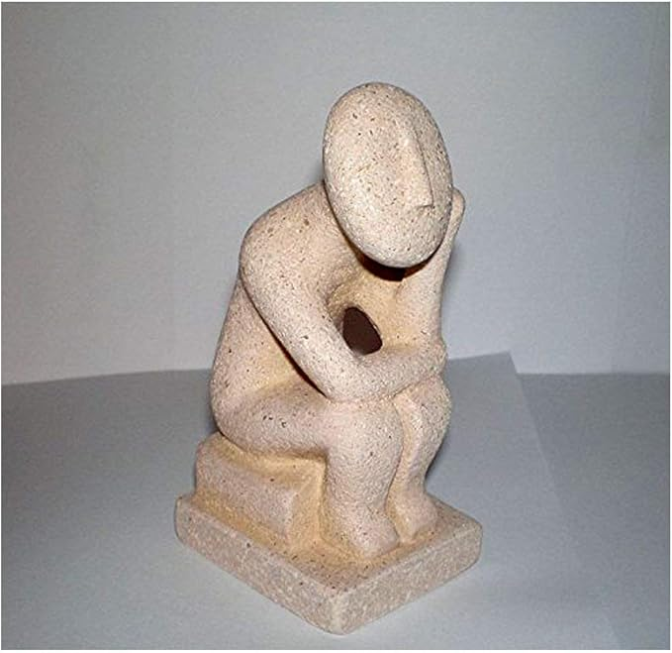

African thinker statue:


A thinker statue from Kasachstan (recent exhibition in the Musee Guimet, Paris)

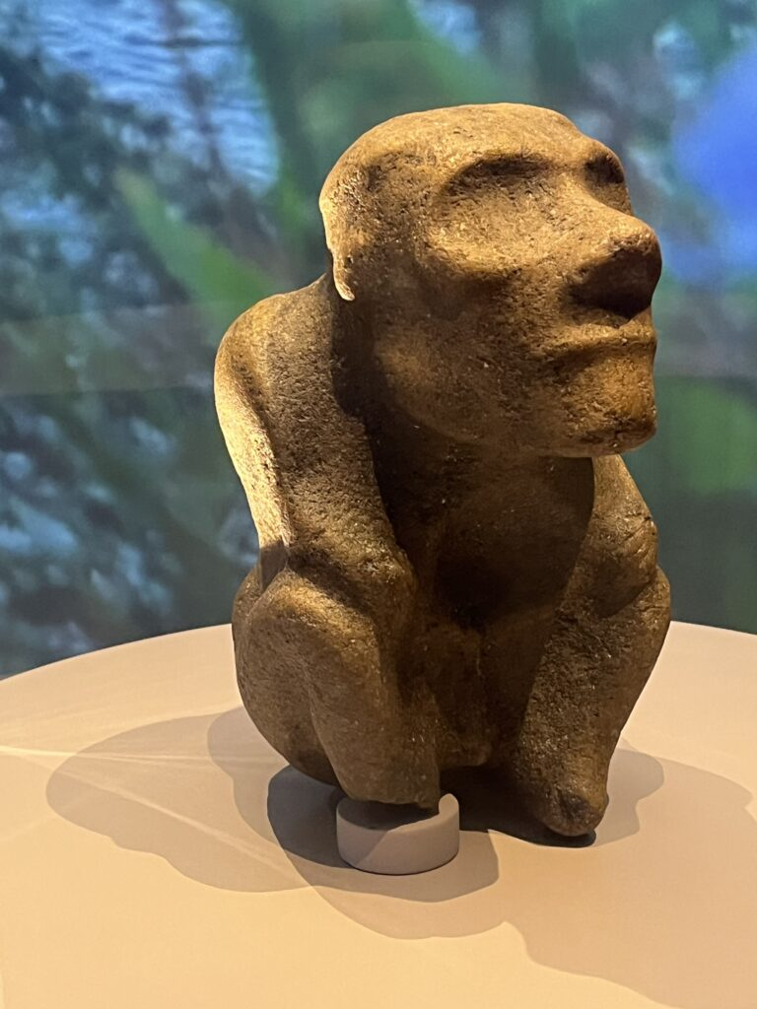

3.2. Female thinker statues

The precolombian Tumiko-LaTolita culture (Columbia and Ecuador)
Female thinker statue (collection Luz Miriam Toro):

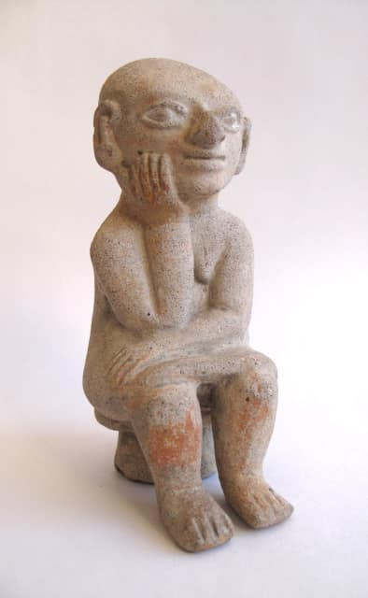

3.3. Thinker statues in Greek and Roman antiquity and in the renaissance

Male thinker statues
Represent real people or types of real people: philosophers or statesmen

Philosopher (Galleria Spada, Rome):

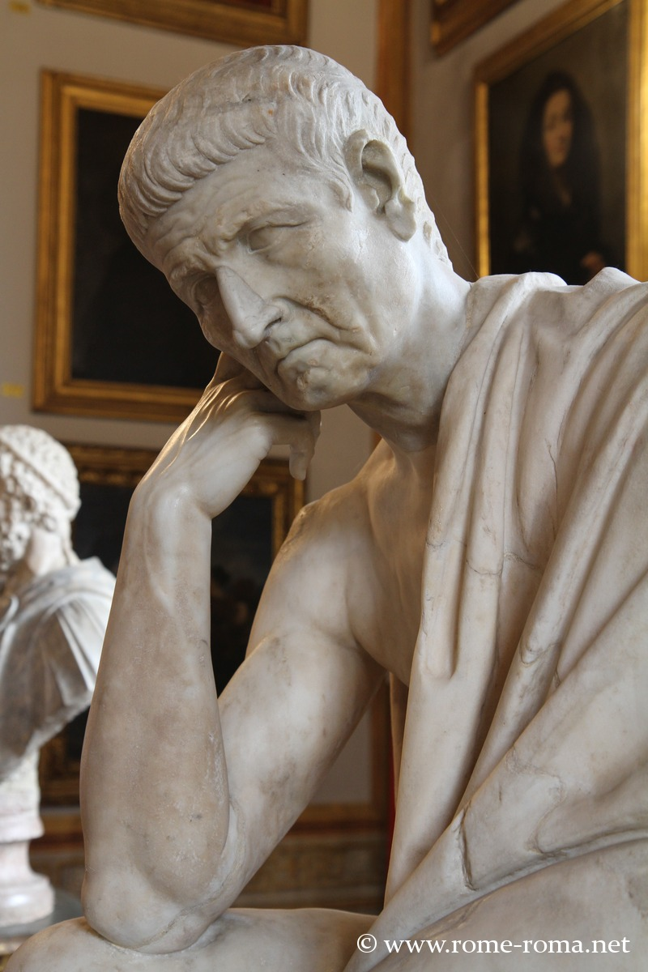

Lorenzo Medici (Michelangelo):

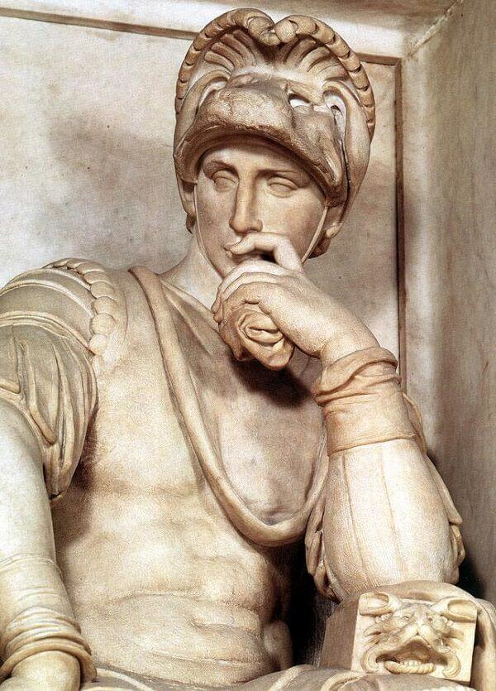

Female thinker statues
Mainly goddesses, muses, and other figures in mythology
Personifications of the arts or of moods

Pensive, mourning Athena (Acropolis, Greece):

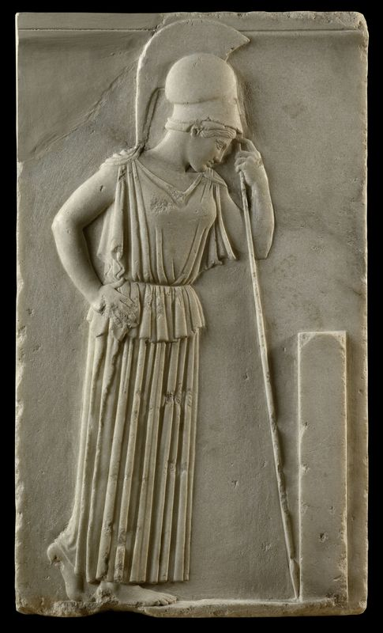

Polymnia – the muse of rhetoric
19th century bronze (my personal collection):

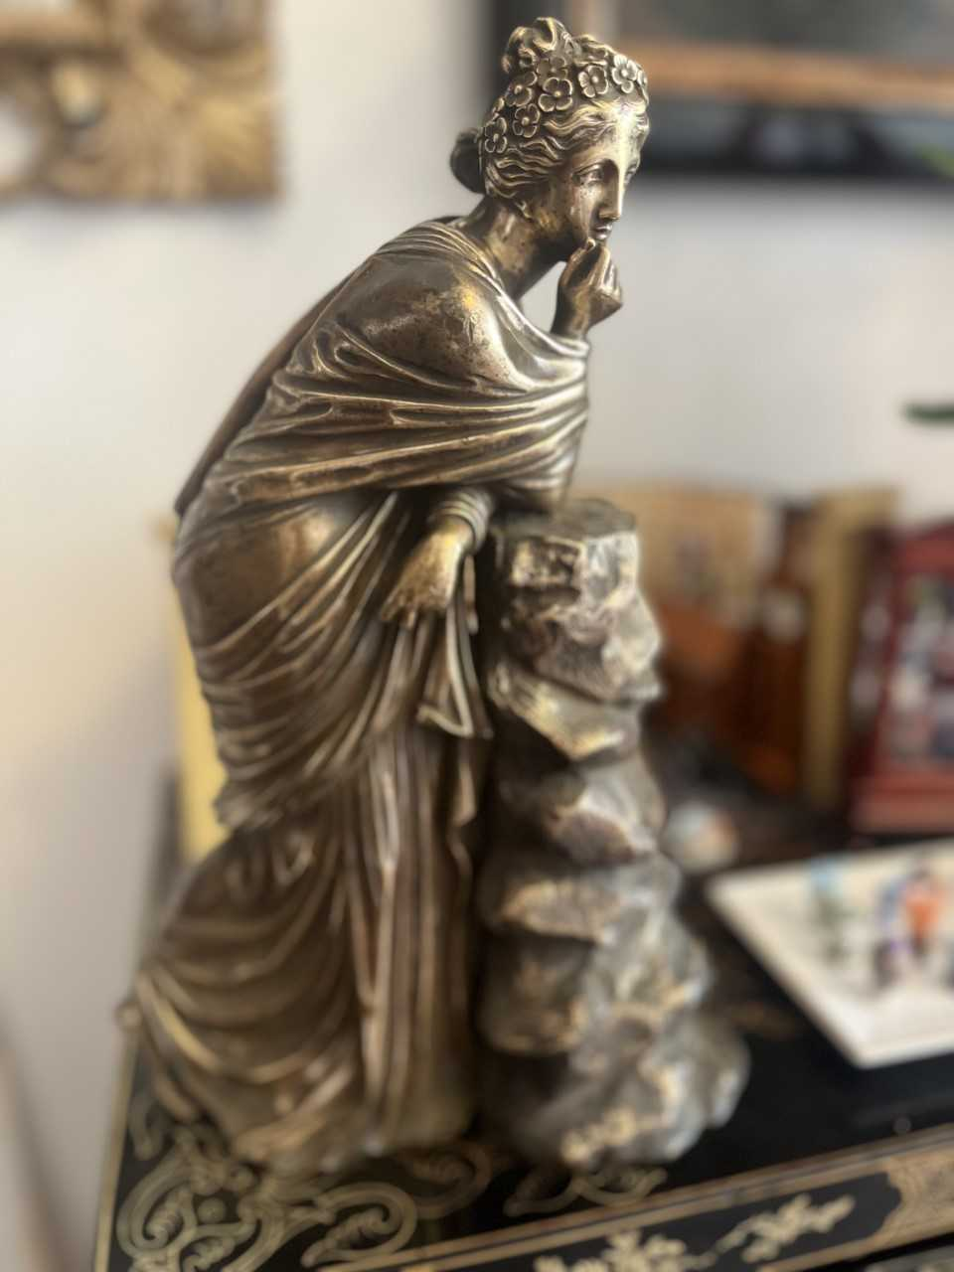
Il Guercino ‘The Persian Sibyl’ (prophetesse of Greek mythology) (17th century, Musei Capitolini, Rome)

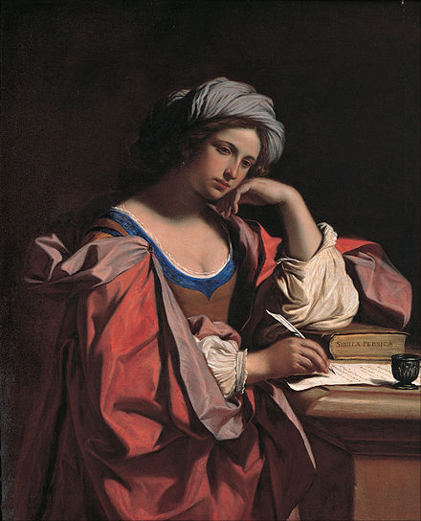

Duerer’s ‘Melancolia’ (1514):

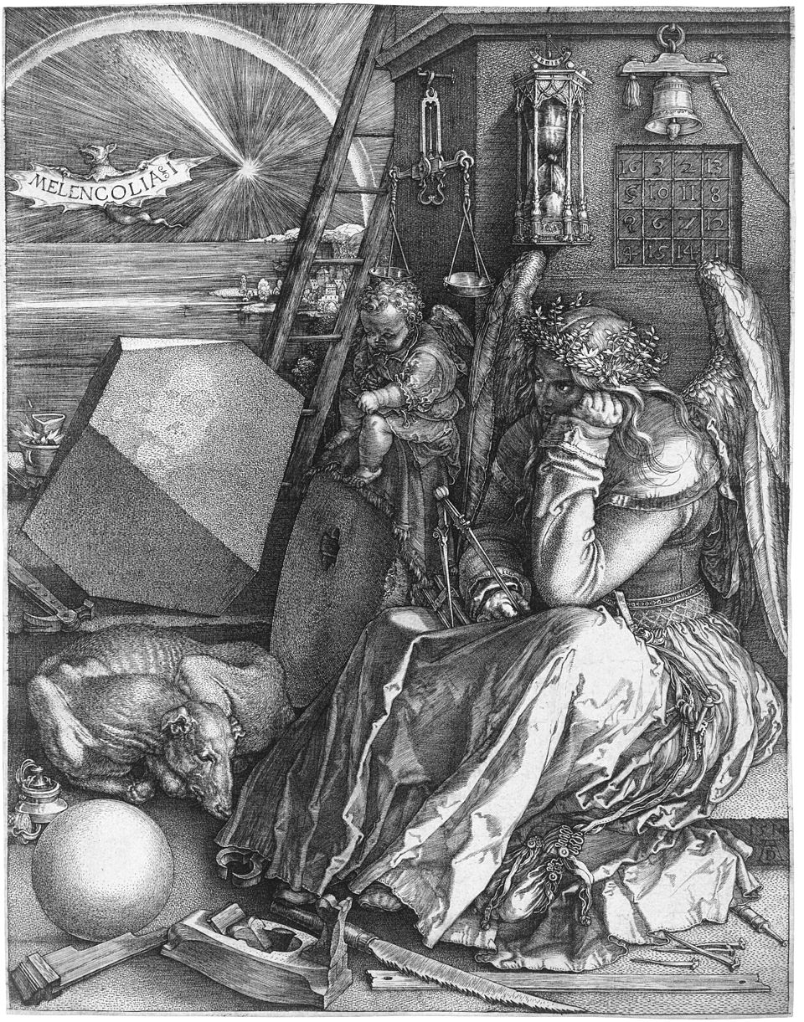

3.4. Thinker images in the 19th century

A female precedent of Rodin’s thinker
Renoir’s ’Jeune fille assise ou la pensée’ (1874)

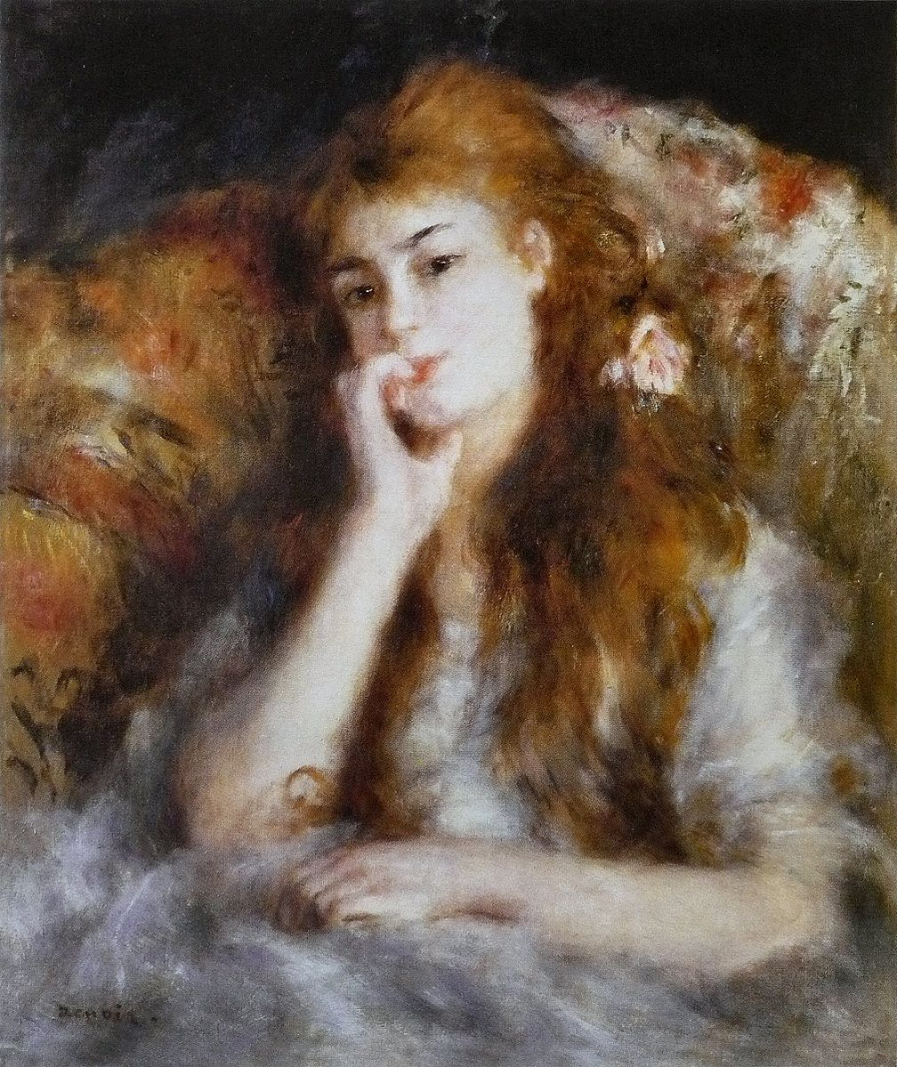

Rodin’s thinker (1904)

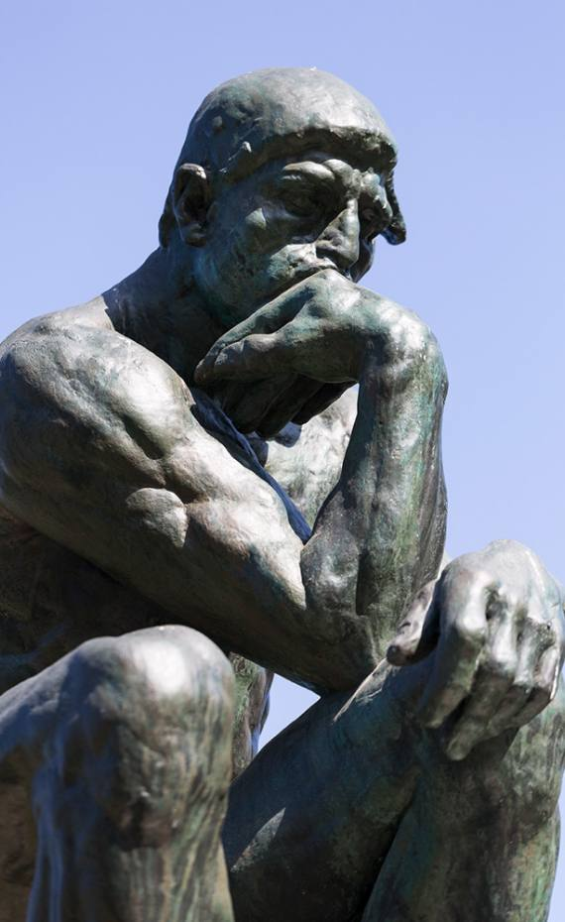

4. The Representations of the Thought

4.1. What is a thought?

A pure content, i.e., an abstract proposition? Or rather something dynamic?
How we talk about thoughts:
A thought ‘occurs’, ‘comes and goes’, ‘emerges’.

4.2. Static conception of propositional content

In sculpture generally reserved for laws

Statue ‘The authority of law’ (US Supreme Court):

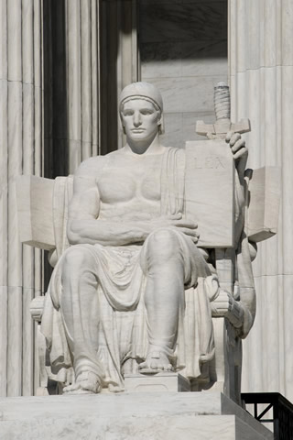
4.3. Representation of thoughts

Thoughts are generally represented dynamically.

A thought as a male angel
Thought as something that comes and goes, as inspiration
Eric Picault’s ‘La Pensée’ (19th century) (my personal collection):

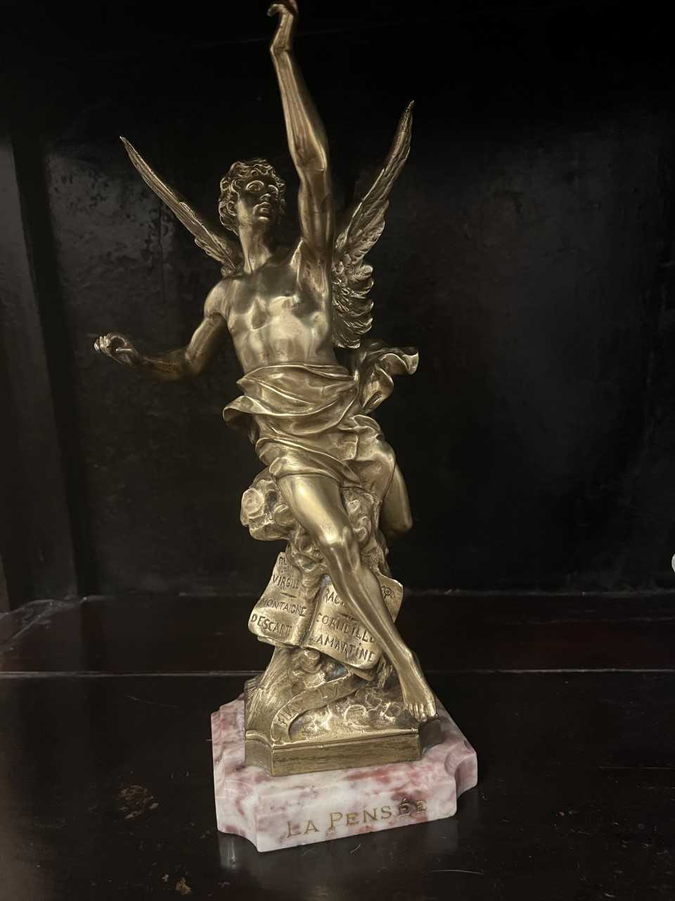

Rodin’s ‘La Pensée’
A thought as something emerging
The head of Camille Claudel emerging from a shapeless mass

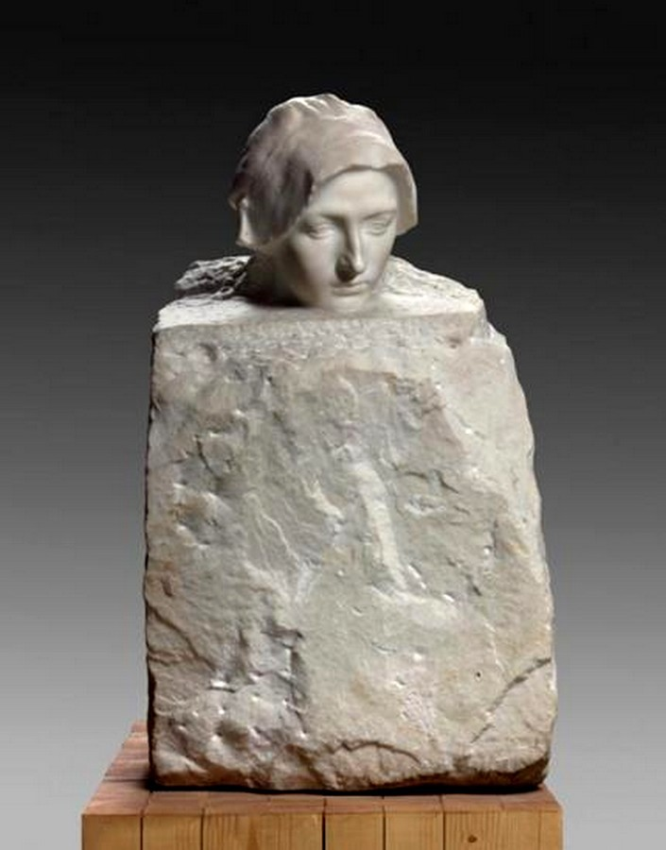
5. The Christian tradition of thinker statues: the pensive, anxious Christ statues of Eastern Europe

The pensive, worrisome Christ of Eastern and Northern Europe (Lithuania, Germany, Poland)
Devotional image of Jesus contemplating, with the crown of thorns and marks of flagellation, shortly before his crucifixion.

Example from a woodblock print by Albrecht Duerer (1511) (title page of a ‘Small Passion’):

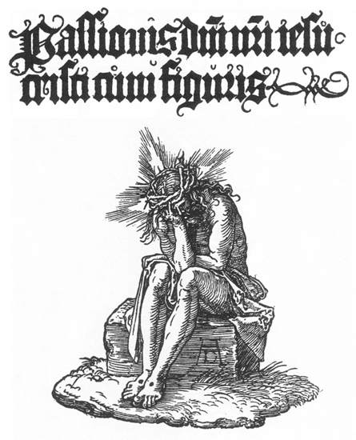

An example of a drawing by Holbein (1515):

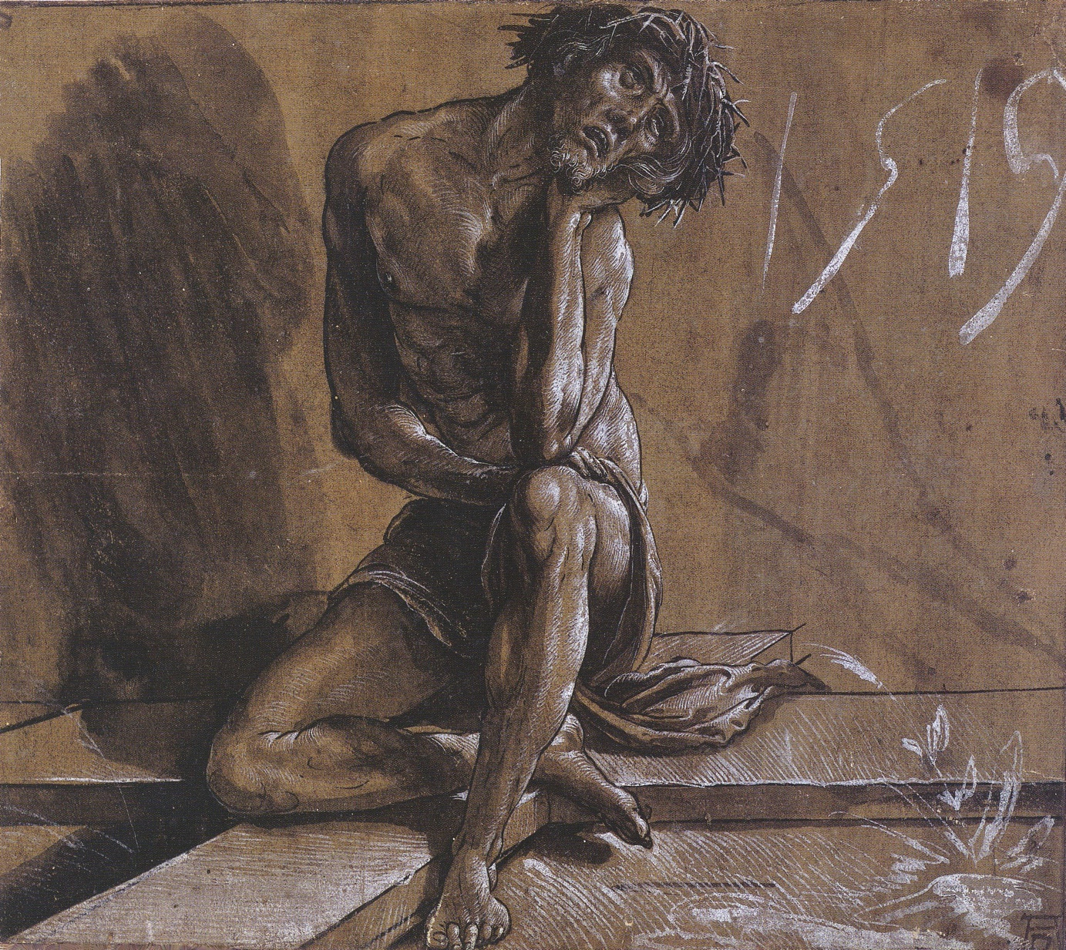

Pensive Christ sculptures made from wood
very popular in Eastern Europe, and still are to this day.
Examples from the Krakow Ethnographic Museum (Poland):

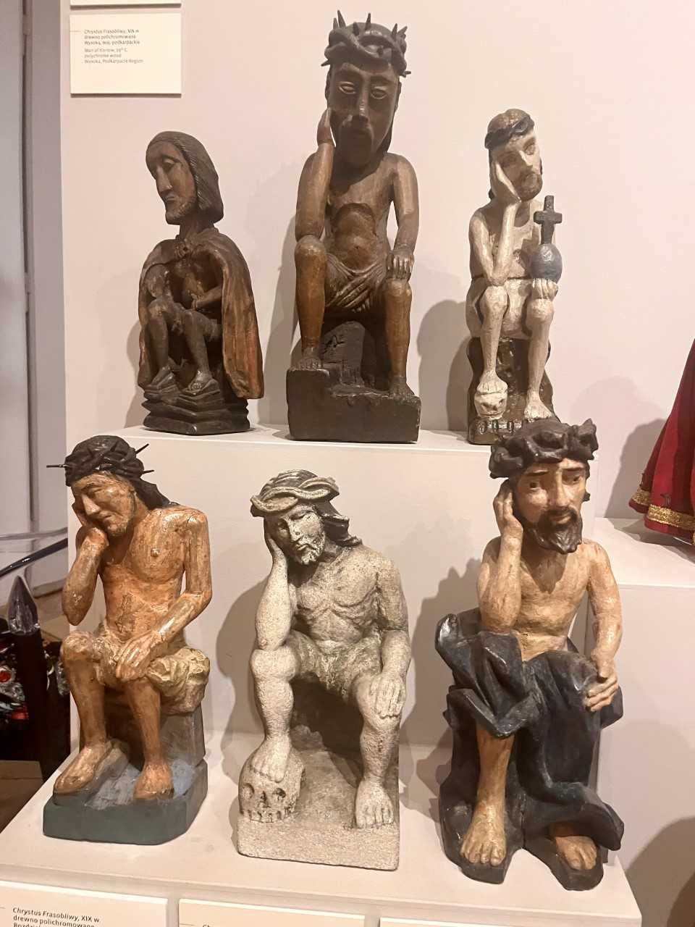
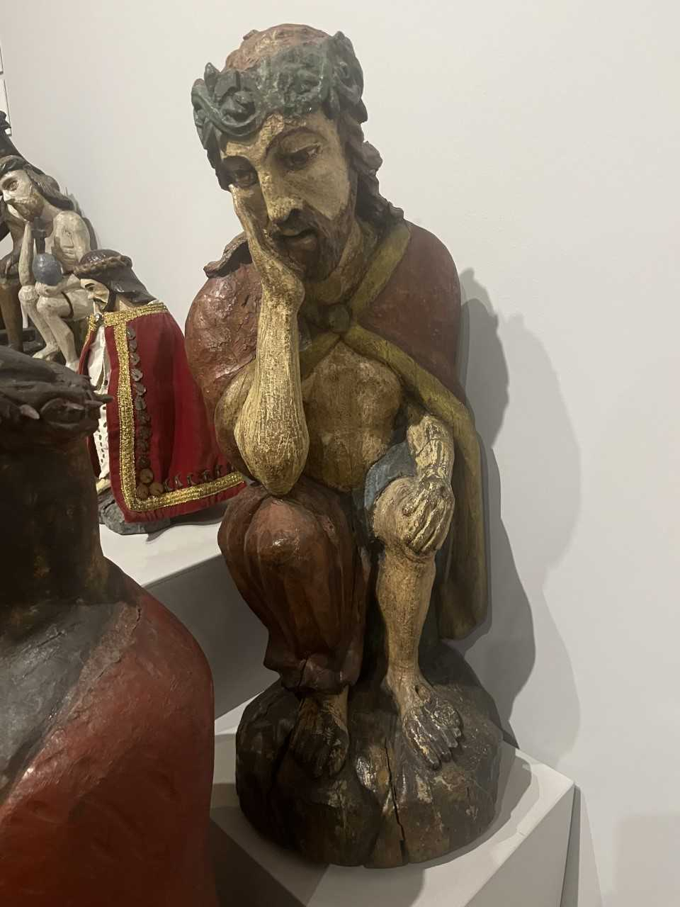

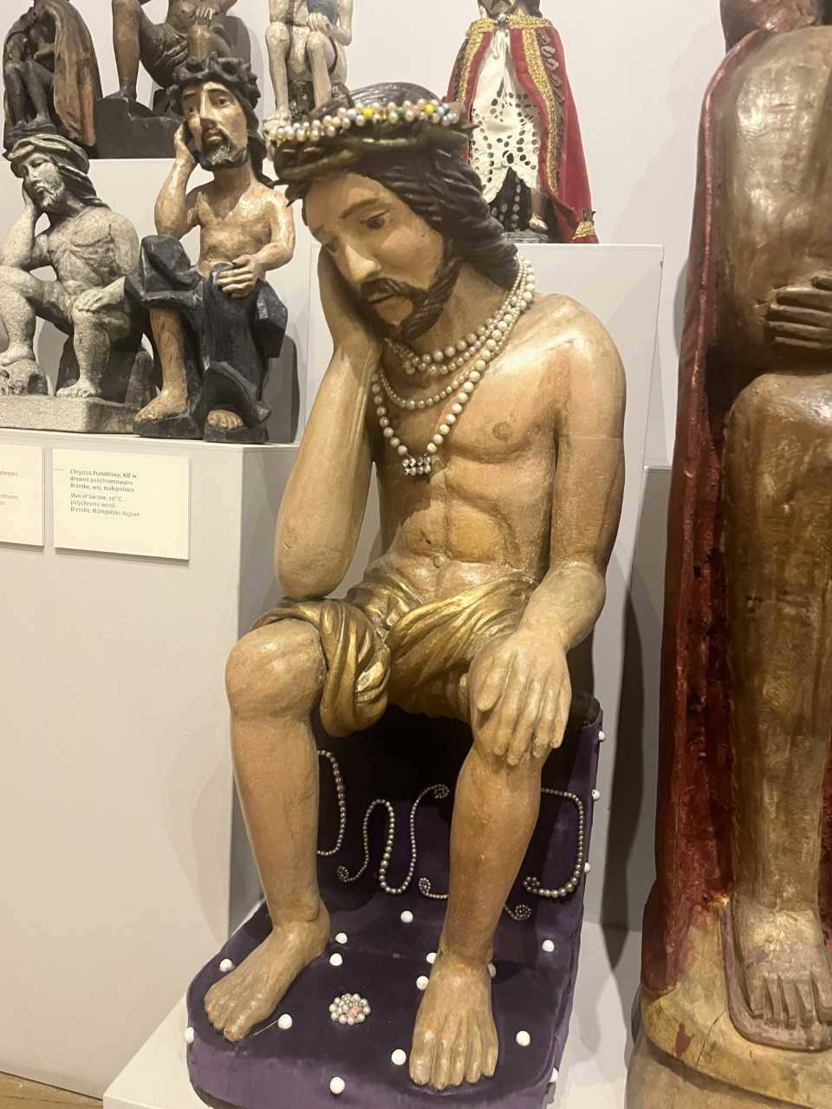
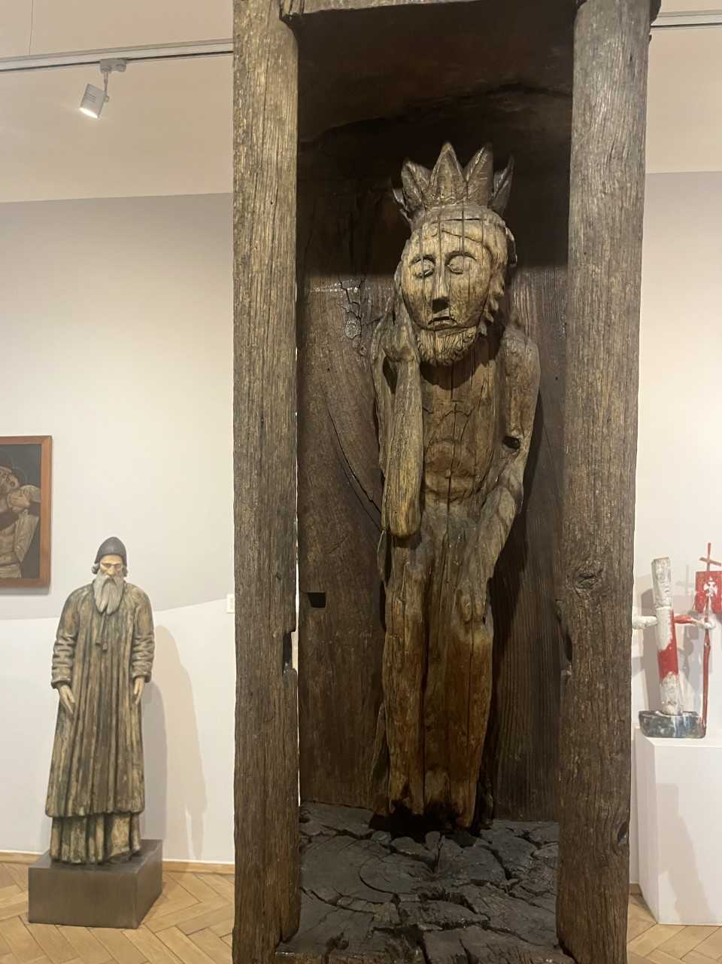

Characteristics of the tradition of pensive Christ images of Northern and eastern Europe
- Anxious, suffering
- No indication of hope, serenity

Was my father not aware of that tradition or just not attracted to it (for himself)?

6. The pensive monumental Christ statue of the Italian Dolomites

A modern sculpture (2009) in the Eastern European tradition of the pensive, worrisome Christ, but with a twist.

The figure

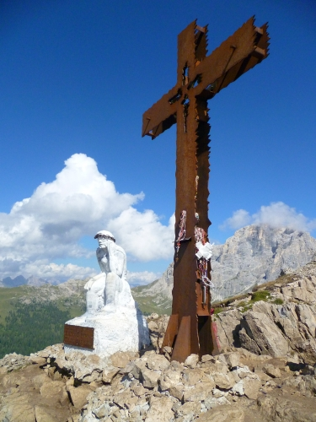

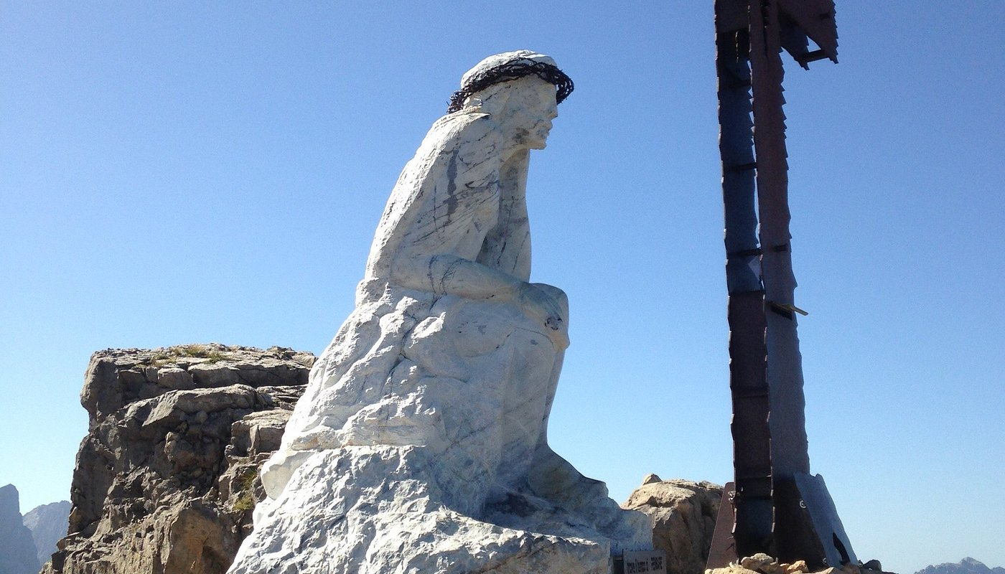

The inscription (!)
Trova il tempo di pensare Find the time to pray
Trova il tempo di pregare. Find the time to think
Trova il tempo di sorridere Find the time to smile


Juergen Moltmann’s famous saying:
‘God weeps with us so that we may someday laugh with him.’

