Presentation given at Pontificia Università Antonianum, April 10, 2025

Thinker Statues and their Religious and Cultural Backgrounds

Friederike Moltmann
CNRS/Université Côte d’Azur

Introduction

Thinker statues and thinker images form a fascinating, but little explored topic.
We are most familiar with Rodin’s rather tortured (and very male) thinker:

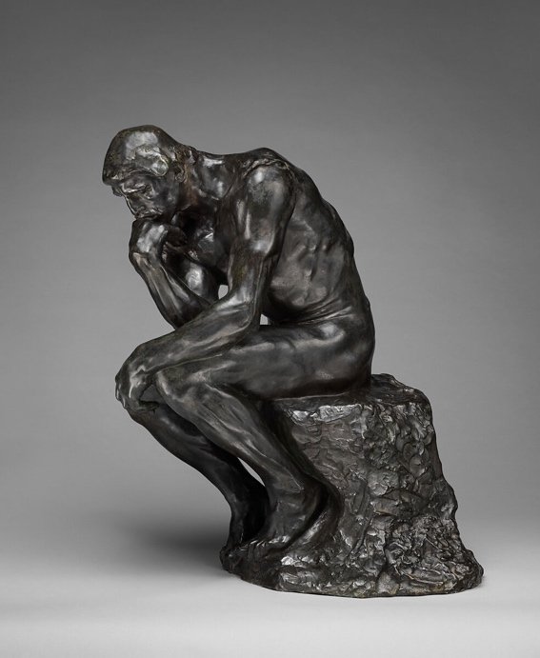

But thinker statues as well as thinker images in painting can be found in various different cultures and at different times in history, and they have played important roles both in Buddhism and Christianity, though in rather different ways.

My father Juergen Moltmann was very much drawn to one particular buddhist thinker statue, the Korean pensive bodhisattva:
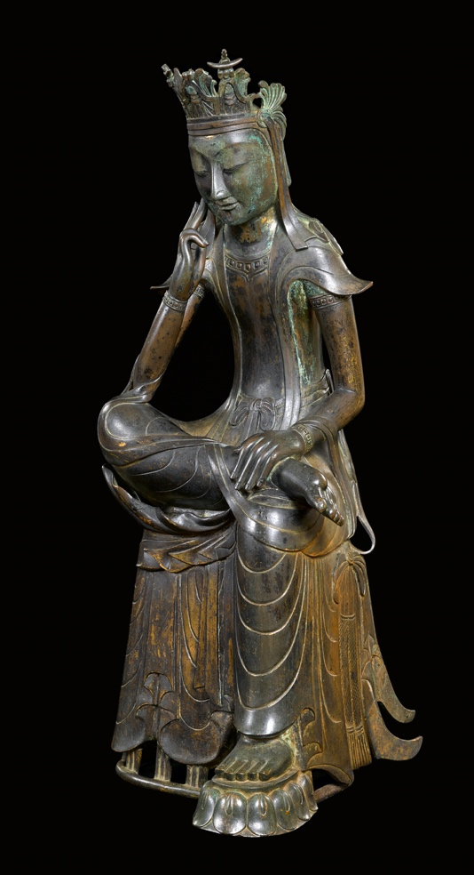

Questions the talk will address
Why was my father so drawn to the Korean pensive bodhisattva?
What kinds of male and female thinker statues or images occur across different cultures?
How are thoughts represented in sculpture?
Is there a Christian tradition of thinker statues?

Plan of the talk
1. Thinker images and their connections to my family
2. Juergen Moltmann’s favorite statue and the notion of hope
3. Thinker statues and thinker images, male and female, throughout different cultures and historical periods
4. The representations of ‘the thought’
5. The Christian tradition of thinker statues: the pensive, anxious Christ statues of Eastern Europe
6. The pensive Christ statue of the Dolomites, who encourages us to smile - like the Korean bodhisattva

1. Thinker images and their connection to my family

My father
Juergen Moltmann, author of the Theology of Hope

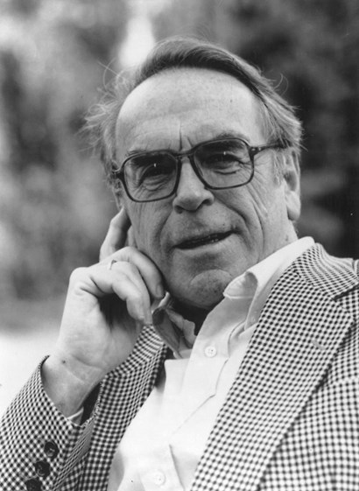

My father’s favorite statue:
The Korean pensive bodhisattva:
It represents Maitreya – the buddha of the future.
The portrait above:
My father’s characteristic thinker pose.
The pose it is that of the Korean pensive bodhisattva, not that of Rodin’s thinker!
My father early 2024 in his study:
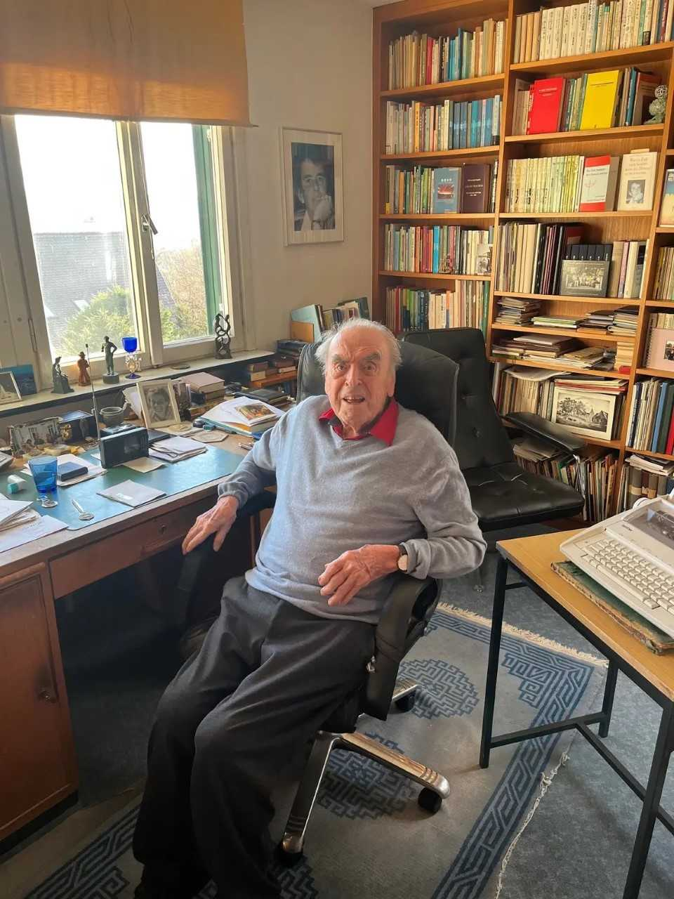

Another one of my father’s Korean thinker statues:

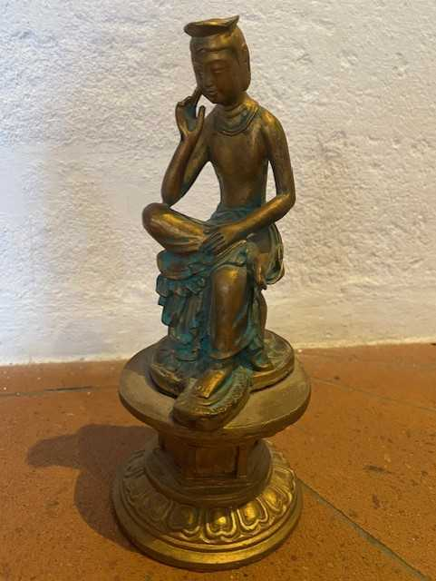

Features of the image
Very human thinking pose
Rather feminine, representing empathy
Serenity and grace:
Smiling, though having thoughts about suffering and death

Me

Philosopher (analytic philosophy) and linguist
Choosing a cover for my book Objects and Attitudes (Oxford University Press 2024)
What the book is about:
Propositional attitudes
Thinking, believing, hoping, desiring, intending, planning, knowing, imagining, doubting
The objects involved in propositional attitudes
The bearers of truth and falsehood or of satisfaction conditions
The book’s claim
The objects involved in propositional attitudes are mind-dependent objects, what we refer to as thoughts, beliefs, hopes, desires, intentions, plans, pieces of knowledge, imaginations, doubts
They are not abstract sentential contents (propositions), as the philosophical tradition holds (Bolzano, Frege, Stalnaker and many others).

Thinker statues:
- represent a propositional attitude (thinking)
- are objects

The chosen cover:
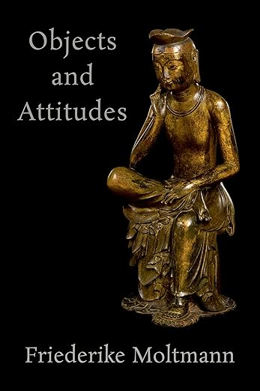
My mother
Elisabeth Moltmann-Wendel, a feminist theologian (‘Freedom, Equality, and Sisterhood’)
a thinker herself, of course.
Here my father’s favorite portrait of her in a thinker pose (see photo of my father’s study)
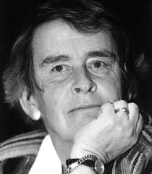
She was not aware of the traditions of thinker images, but this one used to be in her study:
my self-portrait at the age of 15
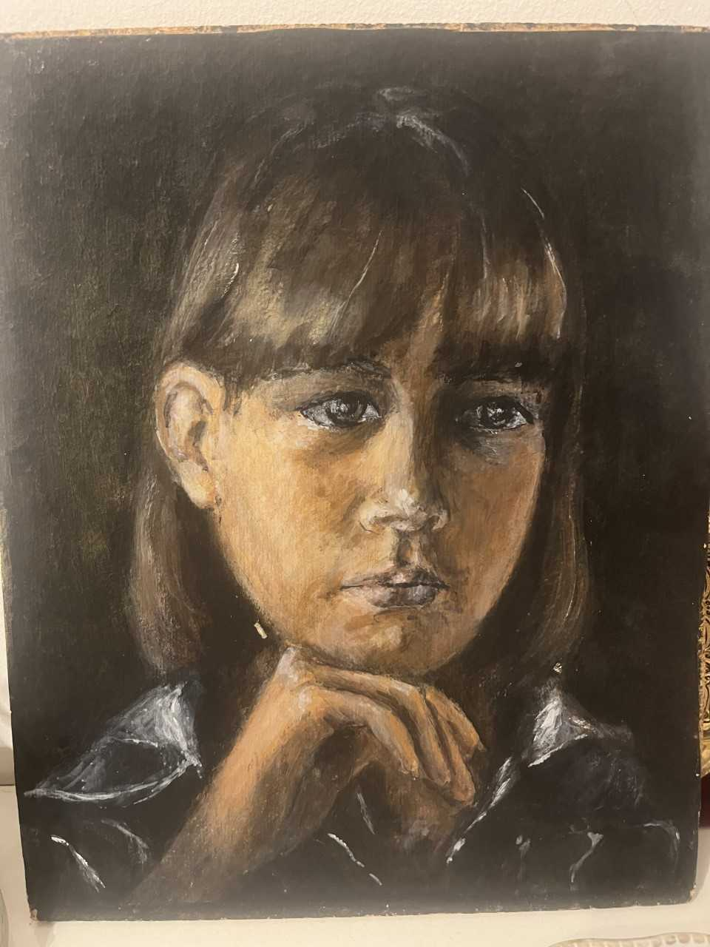
2. The Korean bodhisattva

What is a bodhisattva?
An enlightened being who postpones buddhahood in order to help human beings to their path to enlightenment
Maitreya
The buddha of the future: the buddha that comes to the world in countless years and helps humans find enlightenment

The figure of the Korean bodhisattva:
Hand supporting the chin, half lotus position, crown (often lotus)

Two Korean national treasures (in the Korean National Museum in Seoul):

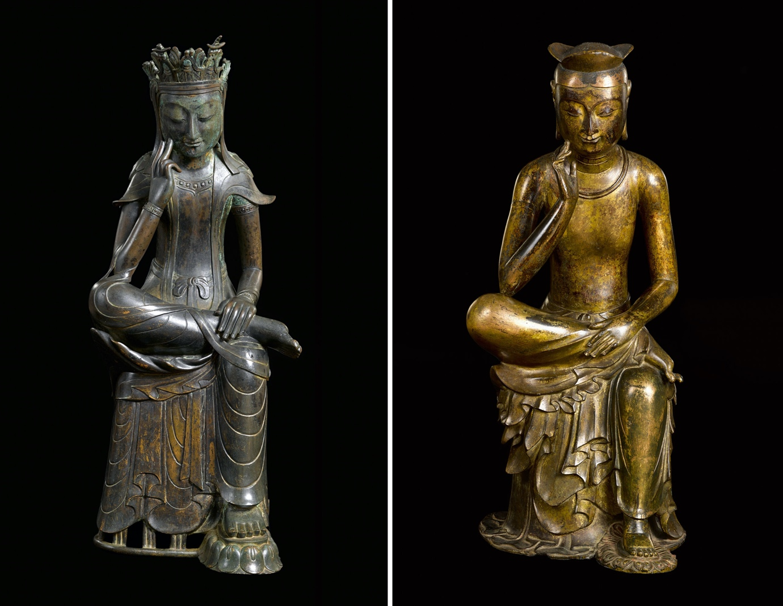

Another example:
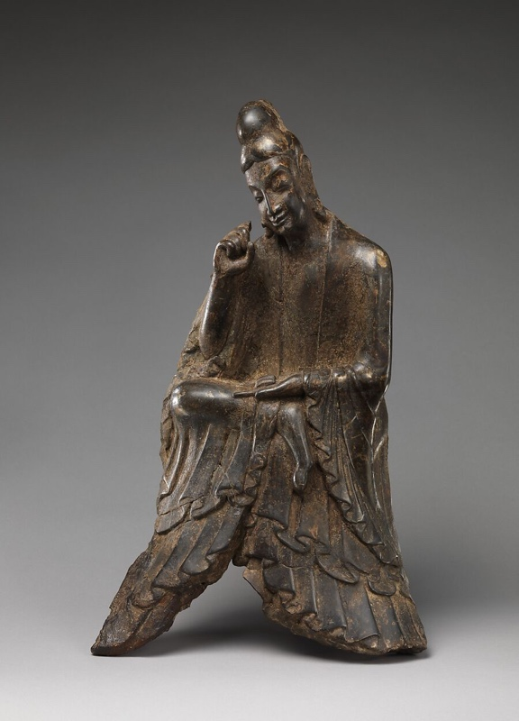

A Korean national treasure and Japanese one (Nara), side-by-side:

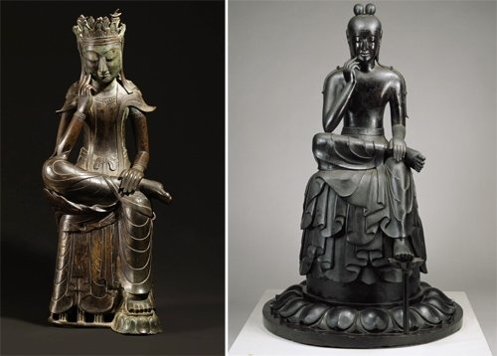

Chinese maitreya
Different seating position: crossed legs
Different hand positions

An example from the Metropolitan Museum of Art, New York:

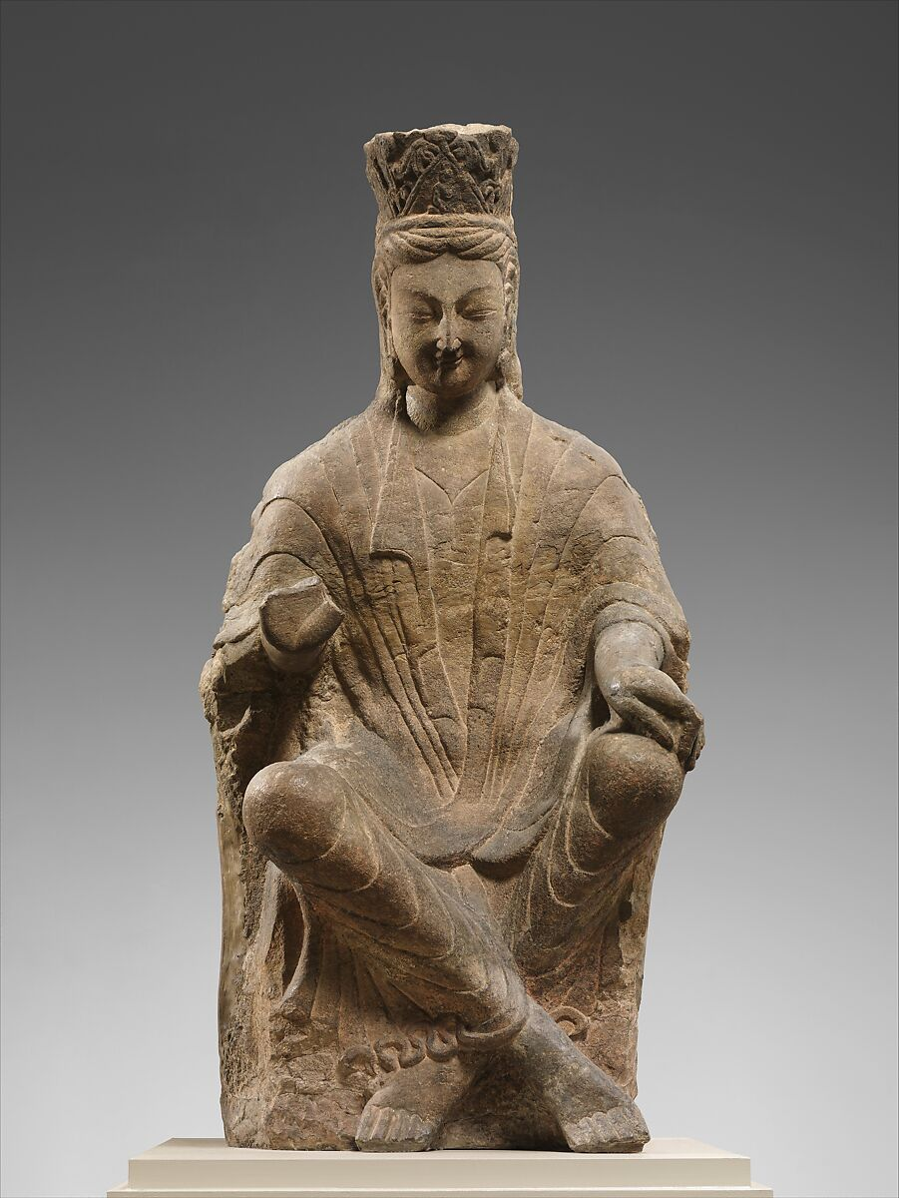

A closely related Chinese buddhist figure: Guanyin
Typical thinker pose of the hand
But bodily position of ‘royal ease’

An example from the Musée Guimet, Paris:

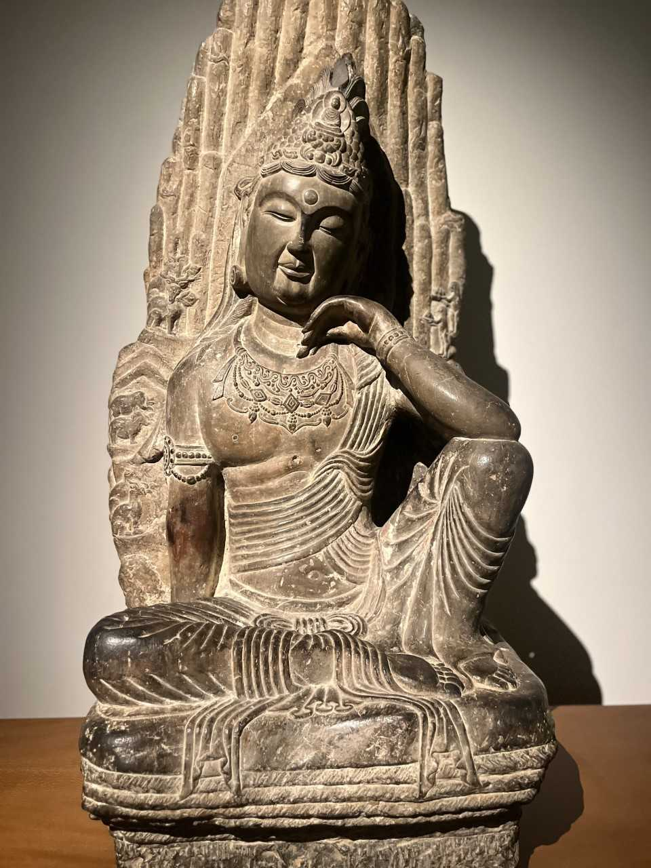
What did my father like the image of the Korean pensive bodhisattva so much?

The notion of hope
Hope is fundamental to Christian faith
Christian hope is for the real world, not for a realm of heaven beyond it

The buddhist figure of the maitreya
The buddha of the future that comes back to the world (in a very distant future) and helps humans obtain enlightenment, serenity, eternal joy

Other features of attraction
The smiling face, even when being aware of death of suffering
The grace and lightness
My father himself liked to adopt the thinker pose of the Korean bodhisattva.

3. Thinker statues in different cultures

3.1. Abstract thinker statues

Cycladic culture:
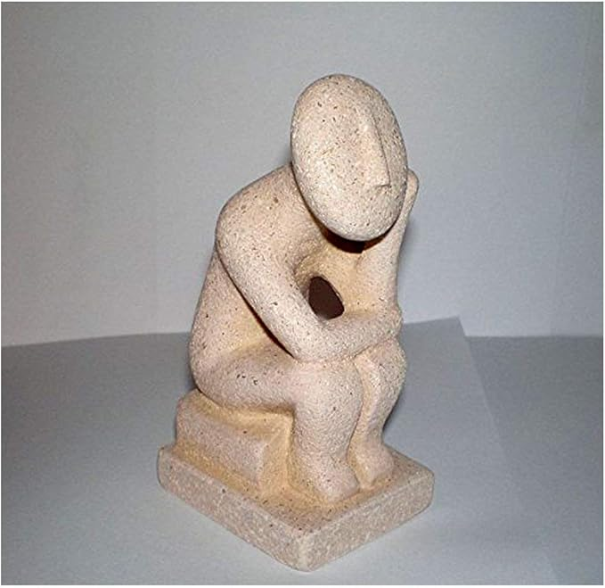

African thinker statue:


A thinker statue from Kasachstan (recent exhibition in the Musee Guimet, Paris)

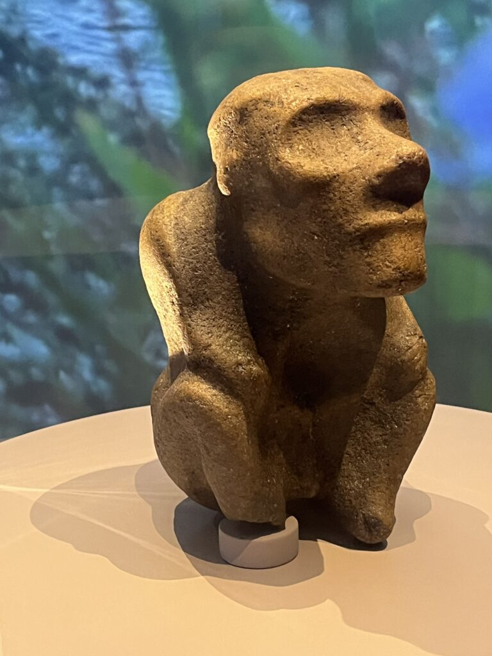

The precolombian Tumiko-LaTolita culture (Columbia and Ecuador)

Female thinker statue (collection Luz Miriam Toro):

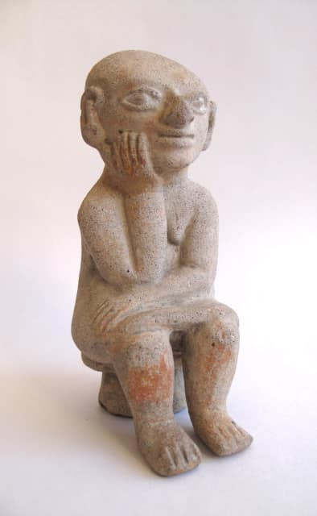

3.2. Thinker statues in Greek and Roman antiquity and in the renaissance

Male thinker statues
Represent real people or types of real people: philosophers or statesmen

Philosopher (Galleria Spada, Rome):

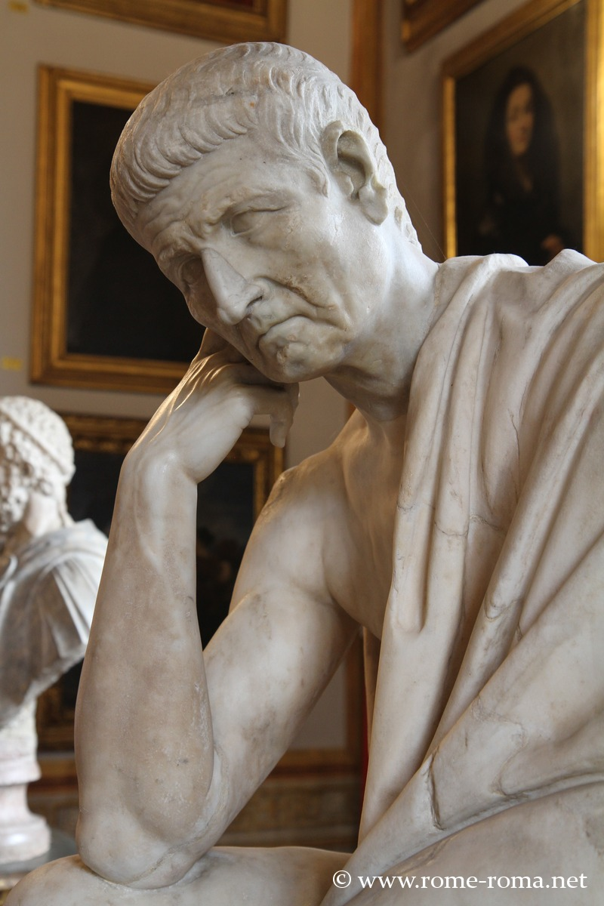

Lorenzo Medici (Michelangelo):

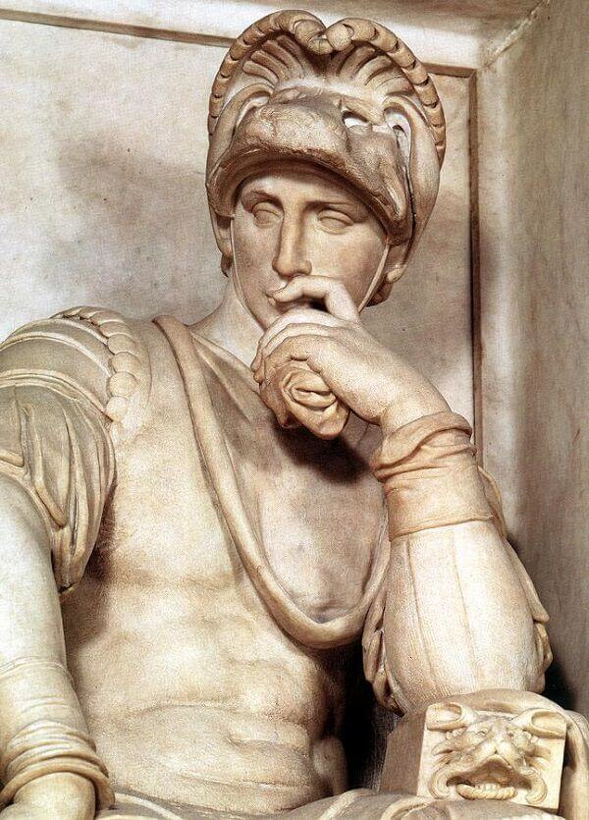

Female thinker statues
Mainly goddesses, muses, and other figures in mythology
Personifications of the arts or of moods

Pensive, mourning Athena (Acropolis, Greece):

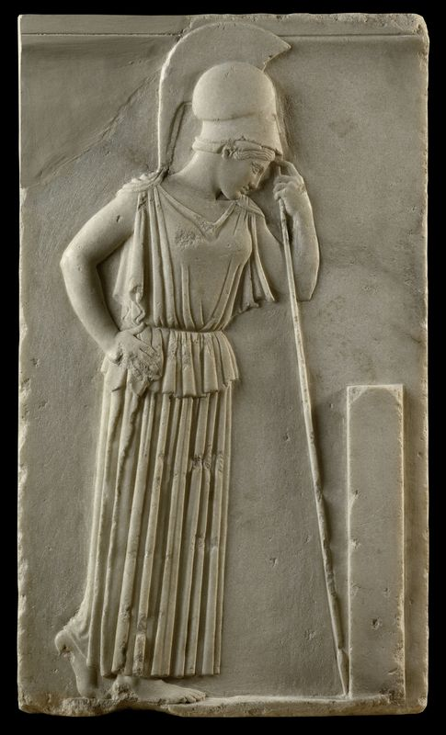

Polymnia – the muse of rhetoric
19th century bronze (my personal collection):

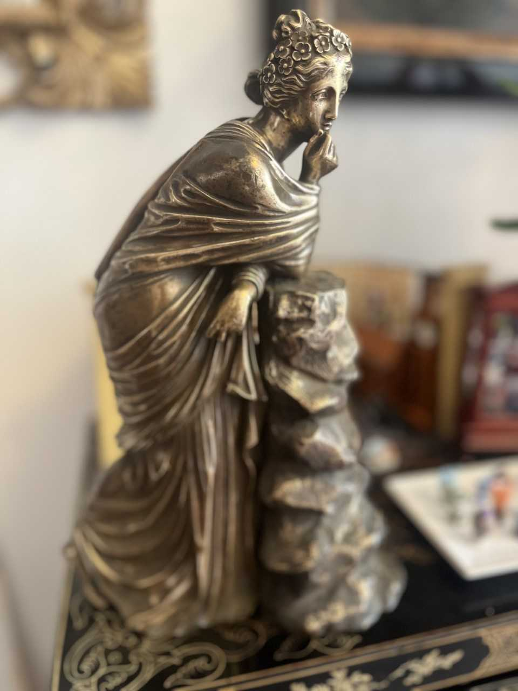
Il Guercino ‘The Persian Sibyl’ (prophetesse of Greek mythology) (17th century, Musei Capitolini, Rome)

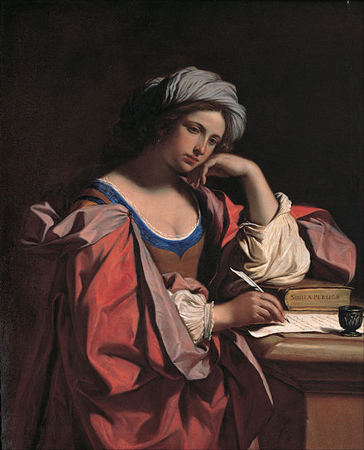

Duerer’s ‘Melancolia’ (1514):

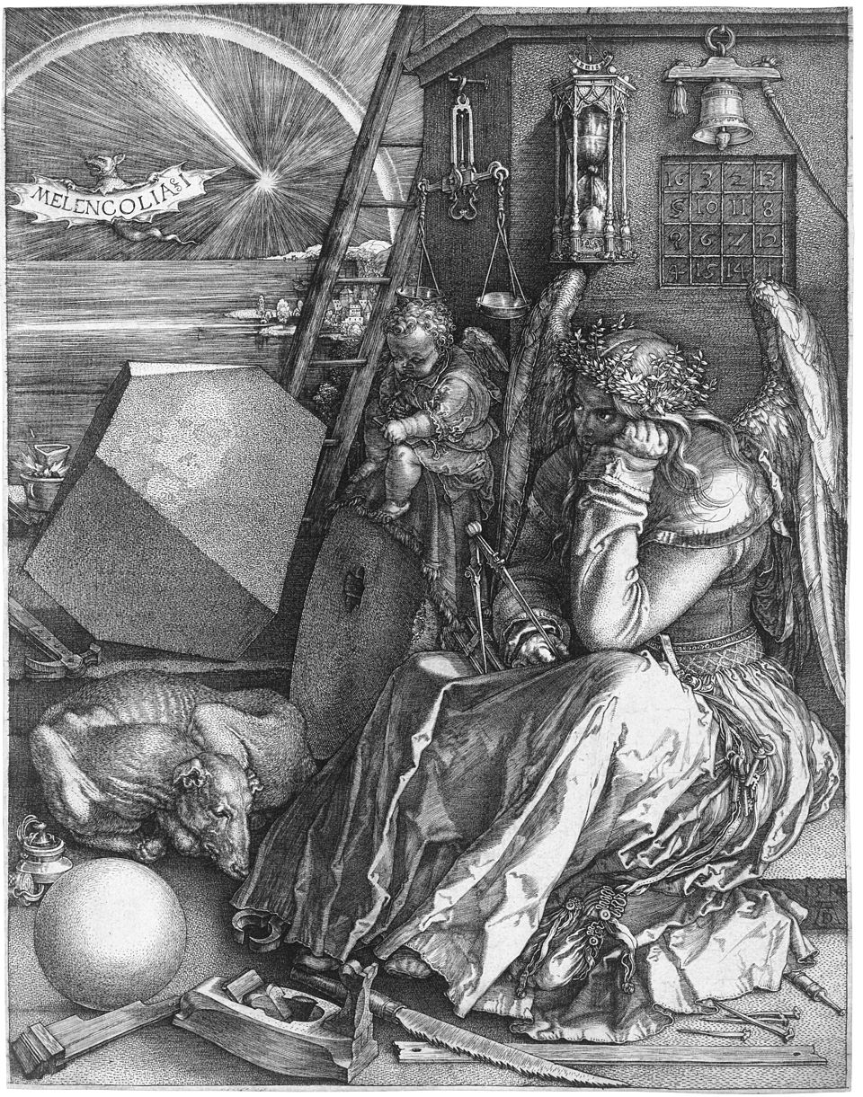

3.3. Thinker images in the 19th century

Renoir’s ’Jeune fille assise ou la pensée’ (1874):

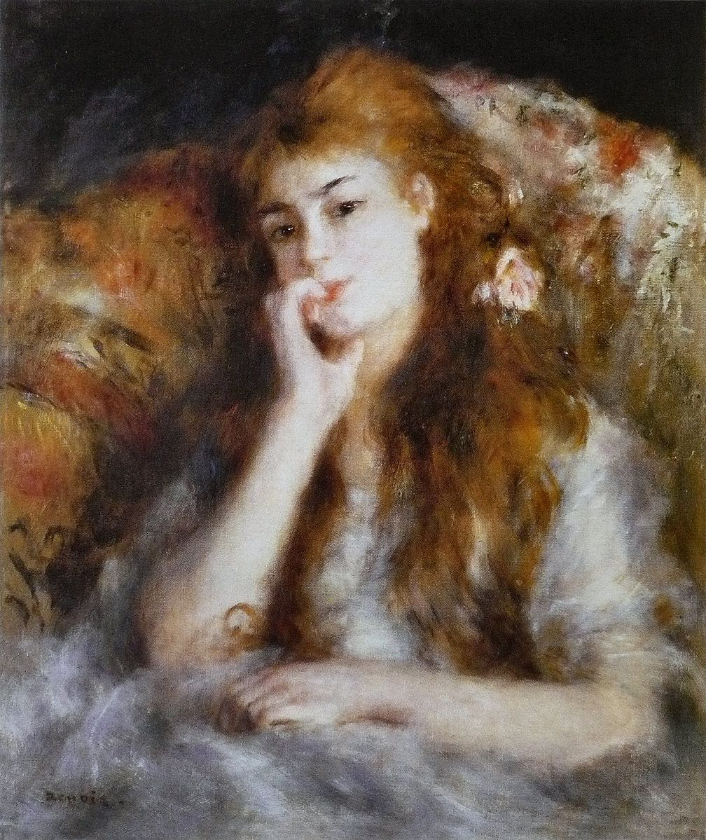

Rodin’s thinker (around the same time):

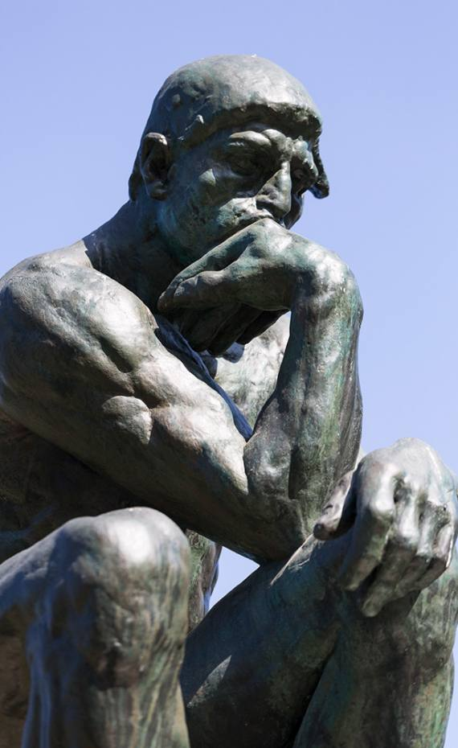

4. The Representations of the Thought

What is a thought?
A pure content, i.e., an abstract proposition? Or rather something dynamic?
This is how we talk about thoughts:
A thought ‘occurs’.
A thought ‘comes and goes’.
A thought ‘emerges’.

Static conception of propositional content:
in sculpture generally reserved for laws

Statue ‘The authority of law’ (US Supreme Court):

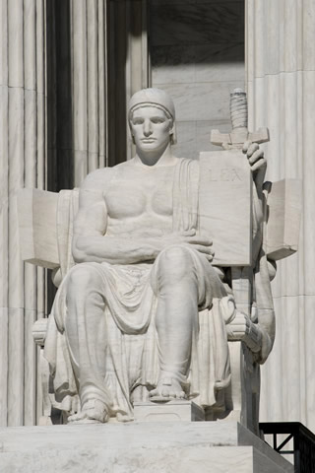

A thought as a male angel:
Thought as something that comes and goes, as inspiration
Eric Picault’s ‘La Pensée’ (19th century) (my personal collection):

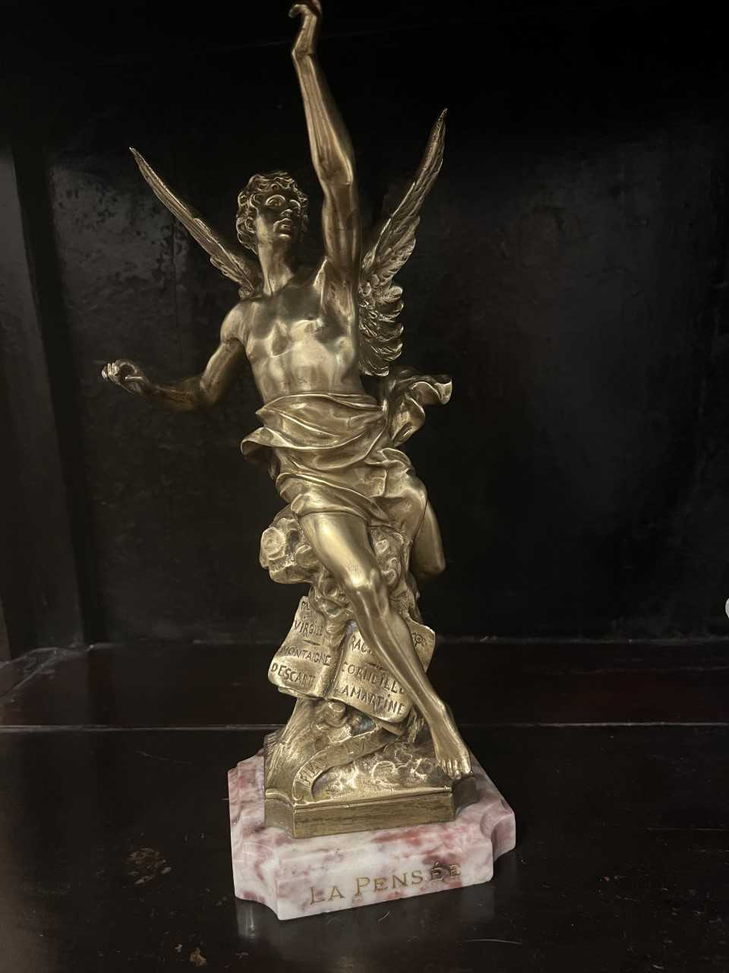

Rodin’s ‘La Pensée’:
A thought as something emerging
The head of Camille Claudel emerging from a shapeless mass

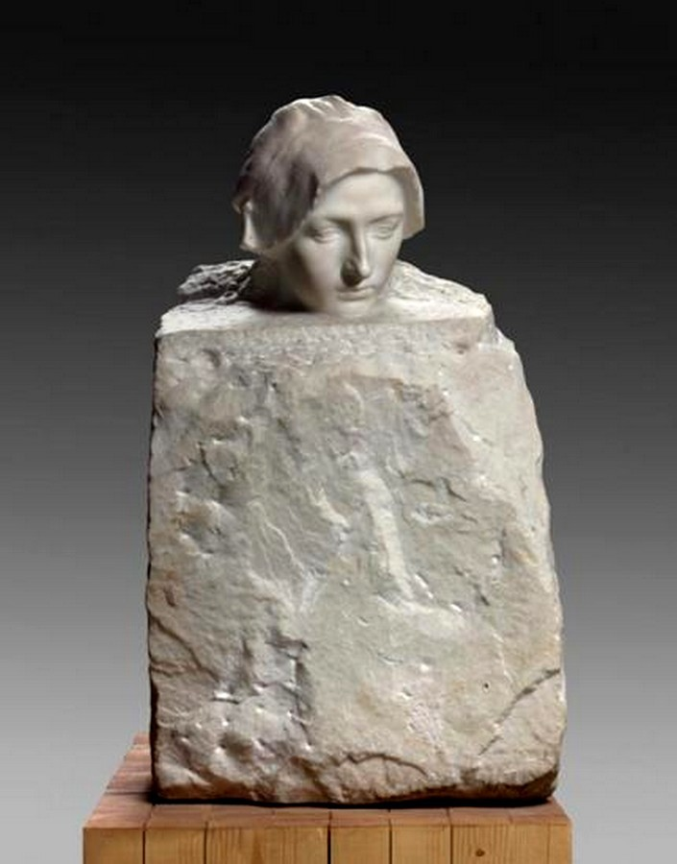

5. A Christian tradition of thinker statues

The pensive, worrisome Christ of Eastern and Northern Europe (Lithuania, Germany, Poland)
Devotional image of Jesus contemplating, with the crown of thorns and marks of flagellation, shortly before his crucifixion.

Example from a woodblock print:

‘Small Passion’, title page (1511) by Albrecht Duerer:

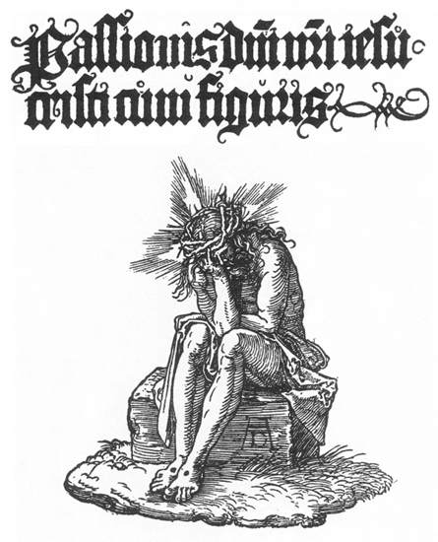

An example from Holbein (1515):

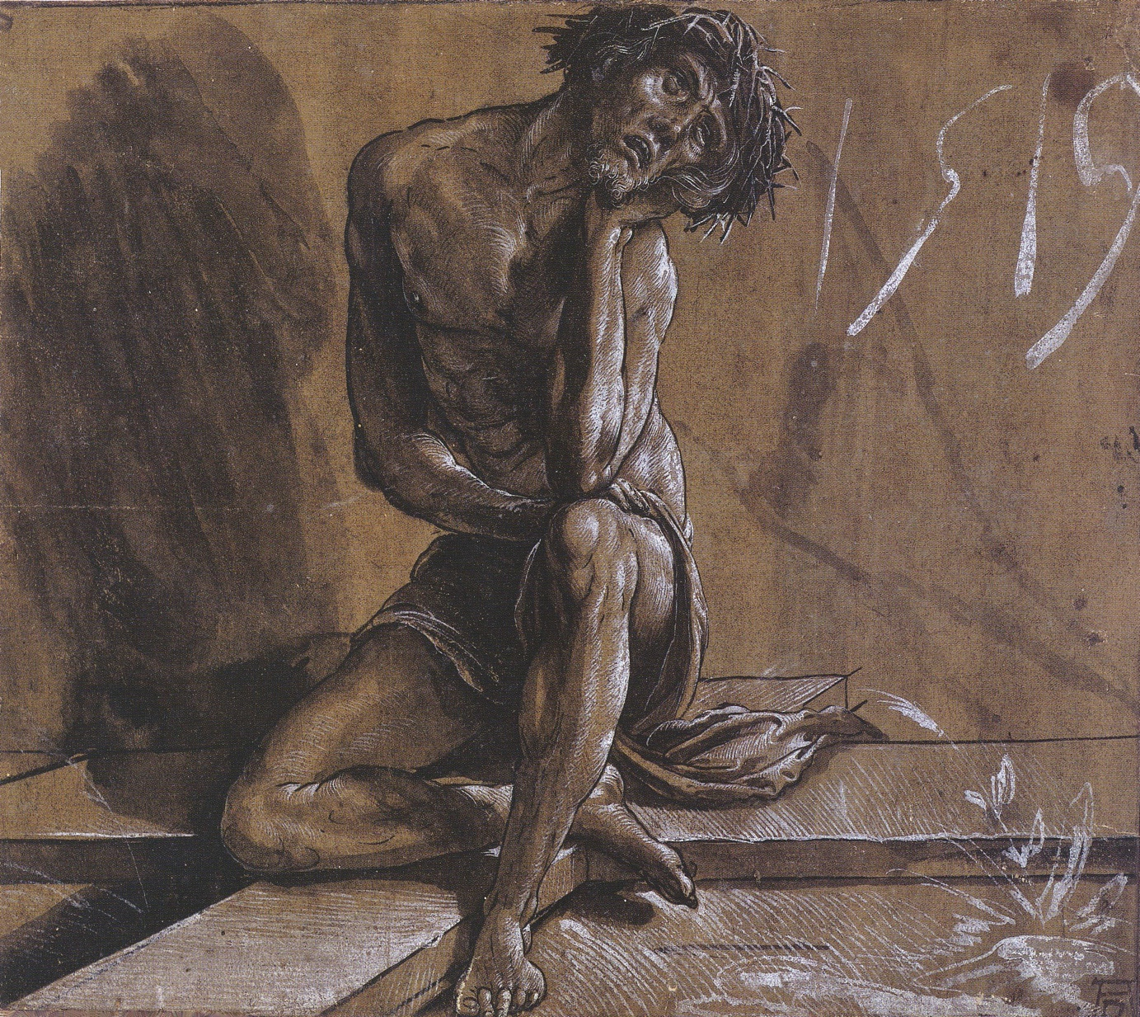

Examples from the Krakow Ethnographic Museum (Poland):

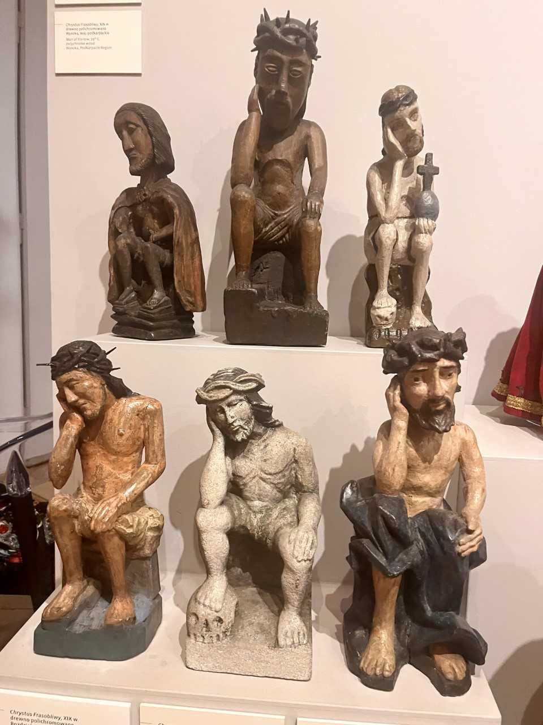

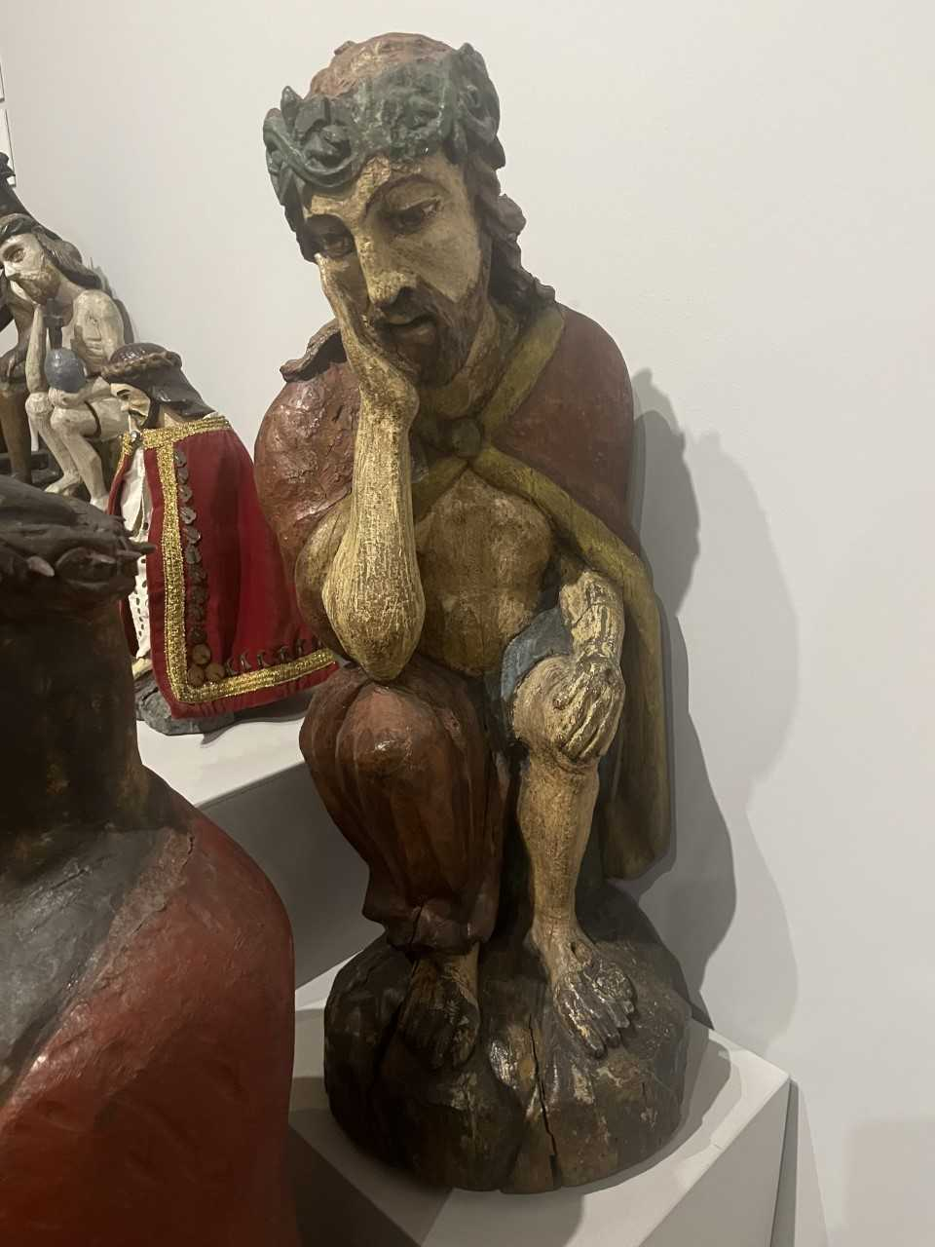

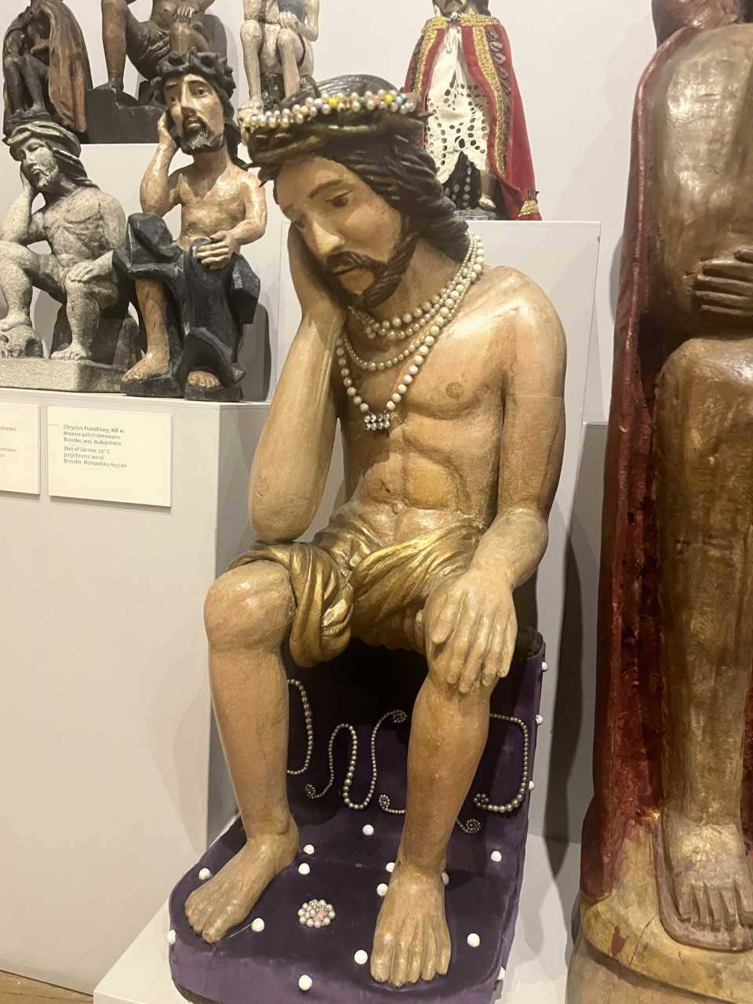
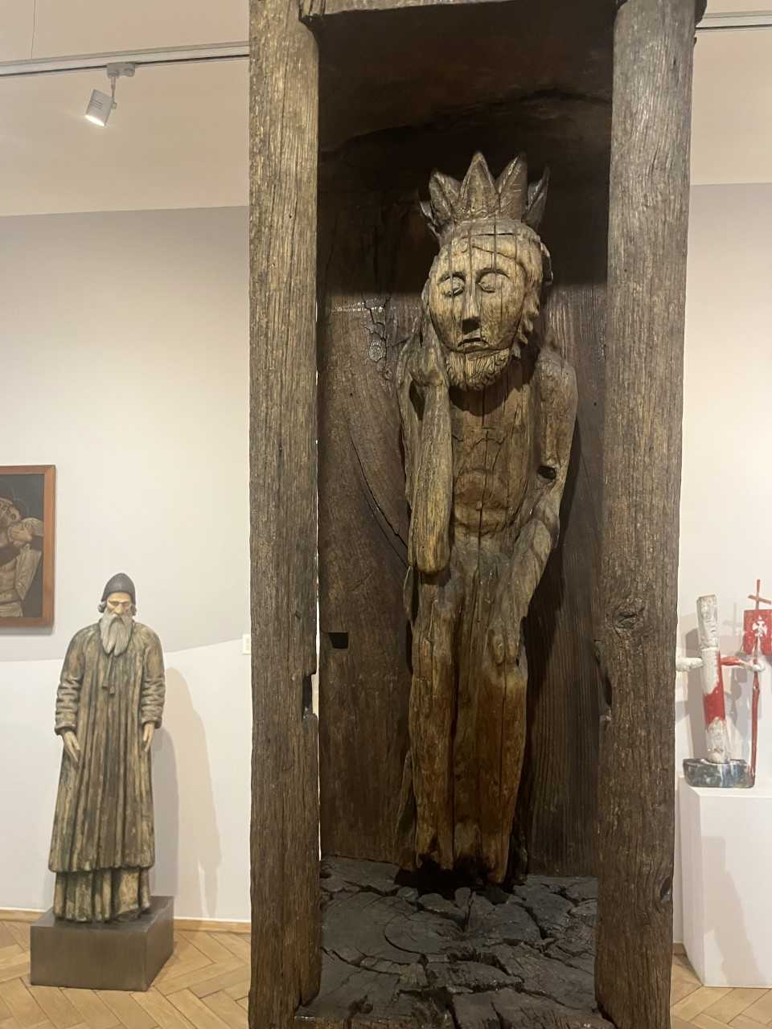
6. The pensive monumental Christ statue of the Italian Dolomites

A modern sculpture (2009) in the Eastern European tradition of the pensive, worrisome Christ, but with a twist.

The figure

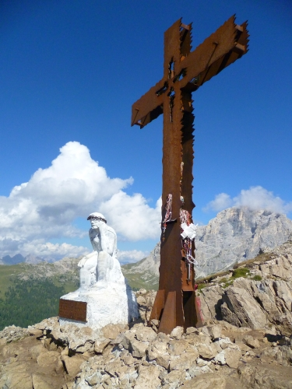

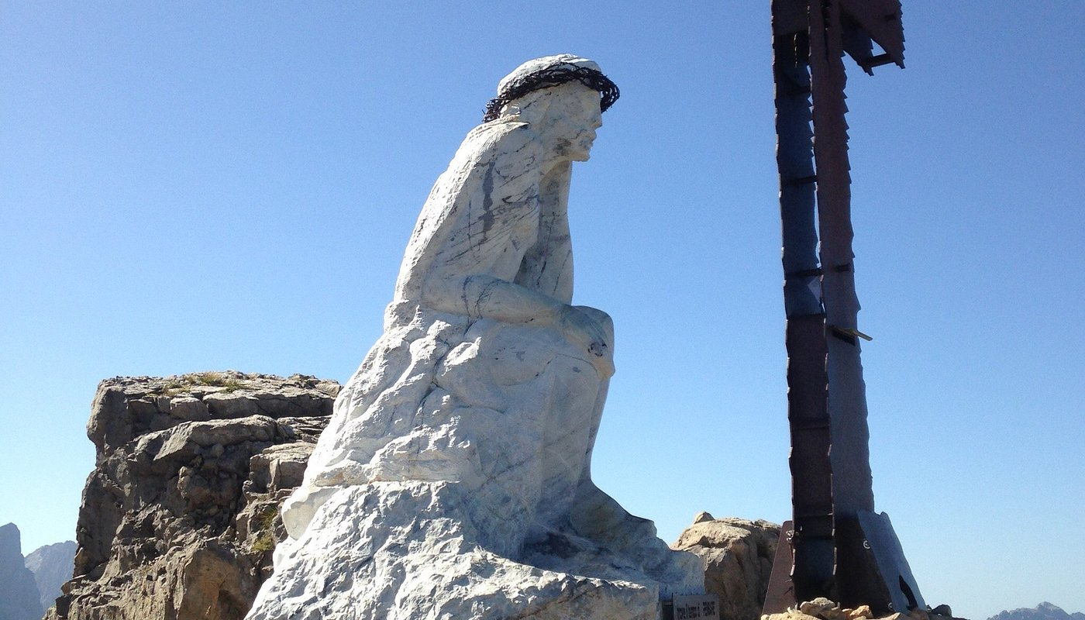

The inscription
Take the time to pray
Take the time to think
Take the time to smile (!)
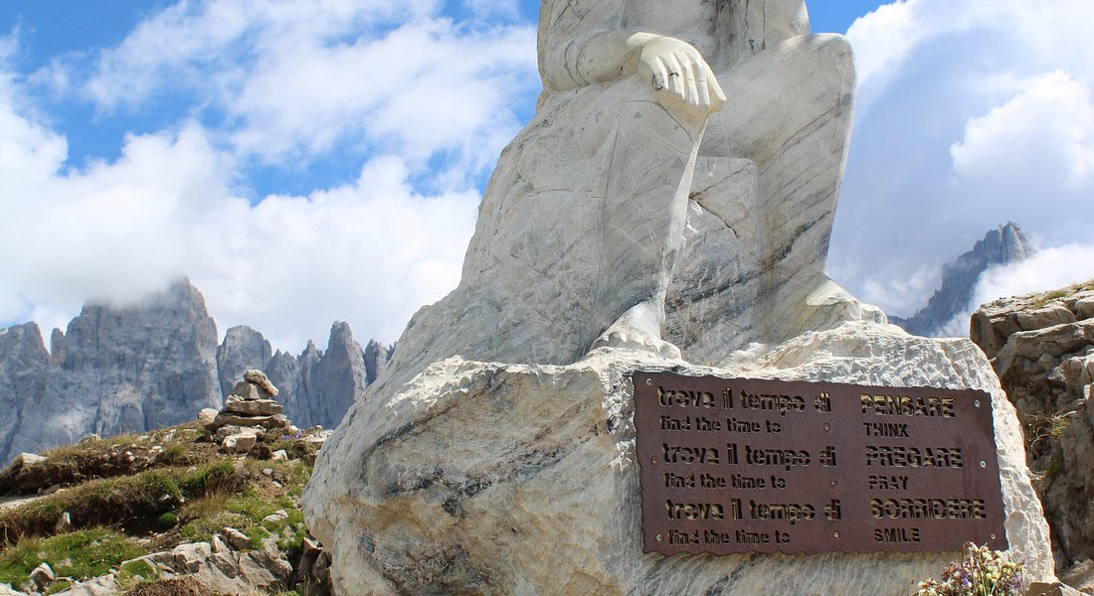

Juergen Moltmann
‘God weeps with us so that we may someday laugh with him.’

